<zsight> zsight tech user guide (ugu)

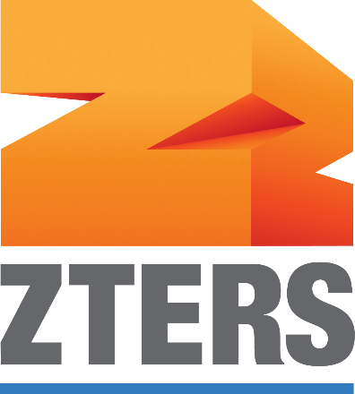

Document ID | DigDev_ZSight_User_Guide_User_Guide_v1.2
Product | ZSight
Environment | QA
Confidentiality Level | Internal / Restricted

Contents
1 DOCUMENT INFORMATION 5
1.1 Validation 5
1.2 Document Distribution 5
1.3 Version Control 5
2 PREFACE 6
2.1 About this document 6
2.2 Related documents 6
2.3 Who should read this document 6
2.4 Terminology 6
2.5 Conventions Used 6
3 ZSIGHT OVERVIEW 8
3.1 Overview 8
3.2 User Interface 8
3.2.1 Login Page 8
4 DASHBOARD SECTION 9
5 CONTAINERS SECTION 10
5.1 Containers List Overview 10
5.1.1 Container Details – Preview Panel 13
5.1.2 Container Details – Full View 13
5.1.3 Container Details – Full View Menu 15
5.1.4 Container Details – Full View Edit Container 15
5.1.5 Container Details – Full View Container Location 16
5.2 Daily Feed section 16
5.2.1 Daily Feed List Overview 17
6 NOTIFICATIONS SECTION 18
6.1 Notification Workflow 18
6.2 Notifications – Open Issue Details 19
6.3 Notifications – Resolved Issue Details 20
7 CUSTOMERS SECTION 21
7.1 Customers List Overview 21
8 SERVICE PROVIDERS SECTION 22
8.1 Service Providers List Overview 22
9 DEVICE MANAGEMENT SECTION 23
9.1 Devices List Overview 23
9.2 Device Details 24
9.2.1 Device Information 24
9.2.2 Management & Inventory 25
9.2.3 Commands 25
9.2.4 Event History 25
9.3 Device Commands 26
9.3.1 Binding Commands 26
9.3.2 Run Mode Commands 26
9.3.3 Command Status 27
9.3.4 How to Send a Command 27
10 WORK ORDERS SECTION 29
10.1 Work Orders List Overview 29
10.2 Available Actions 30
10.3 Work Order and Container Relationship 30
10.4 Create Work Order 30
10.5 Edit Work Order 31
10.6 Remove Work Order 31
11 SETTINGS 32
11.1 My Profile Overview 32
11.2 Account Settings 33
11.3 Team 33
12 ADMIN OPTIONS 35
12.1 Available modules 35
12.1.1 Admin Dashboard 35
12.1.2 Accounts 35
12.1.3 Customers 37
12.1.4 Users 40
12.1.5 Contracts 45
12.1.6 Subscriptions 45
12.1.7 Inventory 45
12.1.8 Installers 45
12.1.9 Reports 45
12.1.10 Audit Trail 45
13 OVERALL SYSTEM FUNCTIONALITIES 48
13.1 Overall System Functionalities Overview 48
13.1.1 Filter 48
13.1.2 Export 49
13.1.3 Show/Hide Column 50
14 User Roles 51
15 WORKING PROCEDURES 52
15.1 Link and Activate a Device 52
15.2 Working Procedure 2 52
15.3 Working Procedure 3 52
16 APPROVAL SIGNATURES 53

DOCUMENT INFORMATION

Validation
Name |  | Role | Date (dd/mm/aa)
Issued by | Oscar Rondon | Technical Writer | 22/10/2026
Verified by
Approved by | Anthony Bures | Digital Development Manager | 22/10/2026

Document Distribution
Normal | Role
Oscar Rondon | Technical Writer
Anthony Bures | Digital Development Manager
Ezequiel Garcia | ZSight Developer
Gabriela Romero | QA Engineer

Version Control
Version | Date | Author | Description of changes
1.0 | 30/04/2026 | Oscar Rondon | 1st version of the ZSight user guide (UGU) document
1.1 | 14/07/2026 | Oscar Rondon | 2nd version of the ZSight user guide (UGU) document – updated in the work orders module and internal functionalities.
1.2 | 22/10/2026 | Oscar Rondon | 3r^{d} version of the ZSight user guide (UGU) document – updated the section “Device Management” which is section 9 in the document.

PREFACE

About this document
This User Guide (UGU) provides an overview of the ZSight application, including its interface, main features, and operational capabilities. It is intended to help users understand how to navigate the platform and use its functionalities to monitor and manage smart trash containers. The document includes descriptions of key modules, user interactions, and supporting workflows.

Related documents
All documents or elements used for reference are presented in the following table:
Title | Reference | Author | Version

Who should read this document
This document is intended for ZTERS team members, customers, and service providers who interact with the ZSight application. It is particularly useful for users responsible for monitoring container status, reviewing operational data, and coordinating service activities. New users can use this guide as a reference to understand the system, while experienced users can use it for feature clarification.

Terminology
Term Used | Description
ZSight | ZTERS application used to monitor and manage smart trash containers with camera-based insights.
Container | A physical waste container equipped with a camera to track fullness and activity.
Fullness Level | Measurement indicating how full a container is, based on image analysis.
Customer | Organization or client using ZSight to monitor their containers (e.g., McDonald's).
Service Provider | Service provider responsible for collecting or servicing containers.
Device | Camera or hardware installed inside a container to capture images and data.
Daily Feed | Visual timeline of images and events captured for containers.
Monitoring | System capability to track container status, activity, and operational events.
Administrator | User with elevated permissions to manage accounts, configurations, and system data.

Conventions Used
The following structures are used as recommendations.
Info: Supplementary Information

Tip: A recommendation or useful advice

Warning: A warning or important notice

Note: A notice.

ZSIGHT OVERVIEW

Overview
ZSight is a management application designed to monitor and manage smart cameras installed in residue containers. It allows customers to visualize the fill level of each container, review captured images, and track container status in real time. The system provides operational visibility to support timely collection and service planning. ZSight also facilitates collaboration between customers and service providers by centralizing container data in a single platform.

User Interface
The user interface starts with the ZSight logging page, and then multiple options show up for customers to keep track of their containers.

Login Page
The Login Page allows users to securely access the ZSight application by entering their registered email address and password.
Tip: Access to the application is restricted and requires connection through the ZTERS VPN.

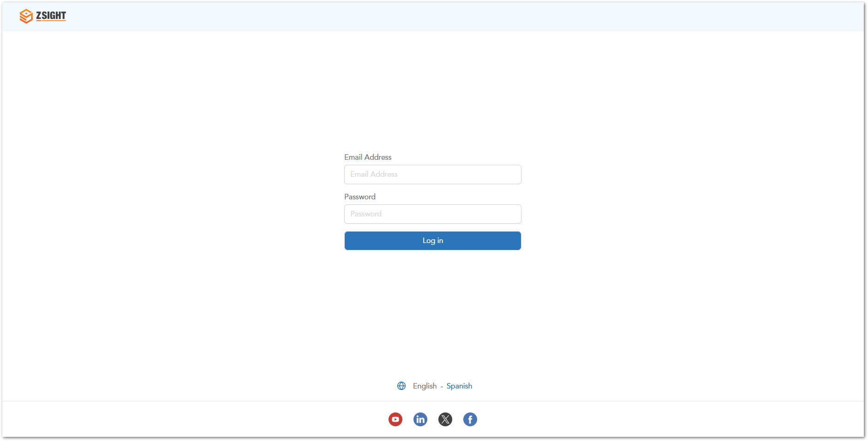

DASHBOARD SECTION
The Dashboard provides a high-level overview of container activity and key operational metrics. It allows users to quickly understand the overall status of their containers and identify areas that require attention.
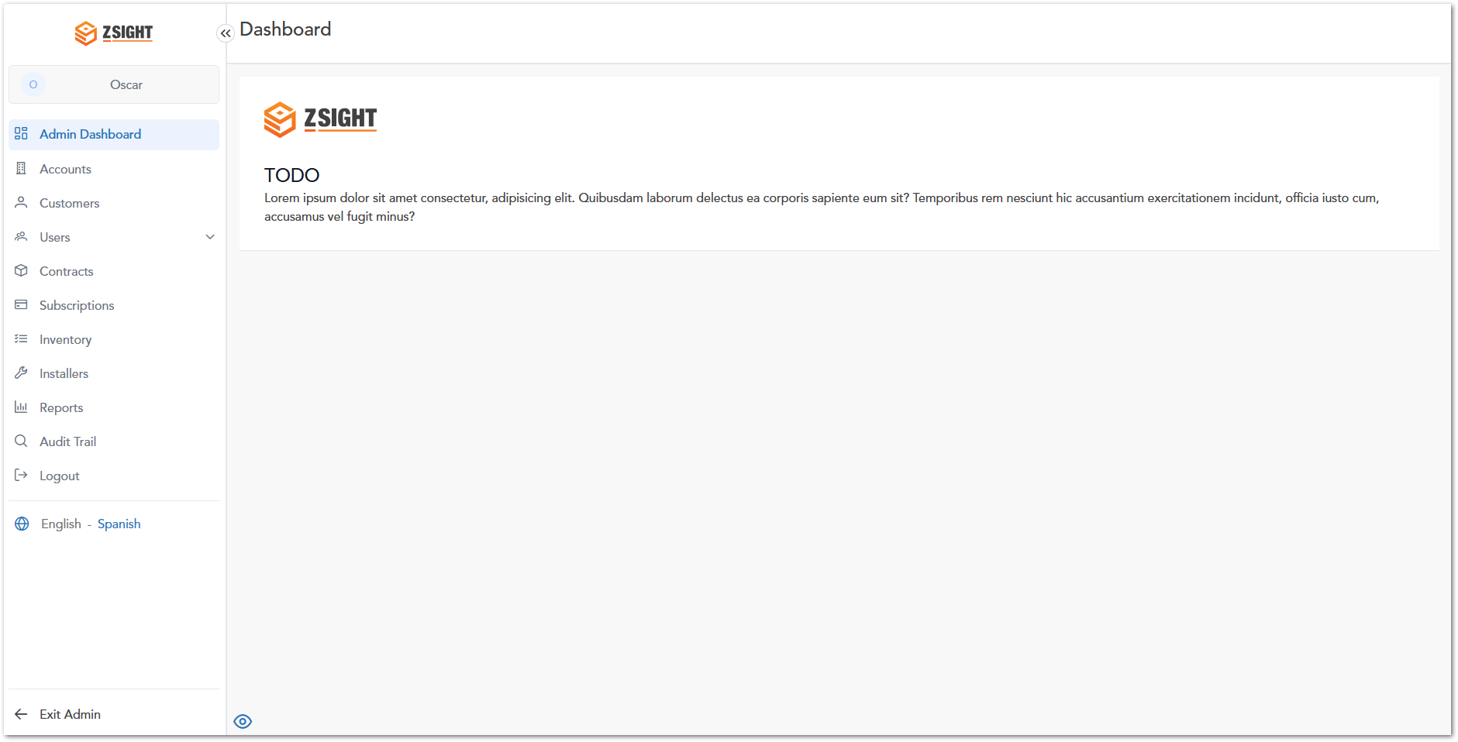

CONTAINERS SECTION
The Containers module allows users to view and monitor all registered containers within the system. It provides real-time visibility into container status, including fullness levels, recent activity, and service history. Users can access detailed information for each container, enabling better decision-making for waste collection and operational planning.
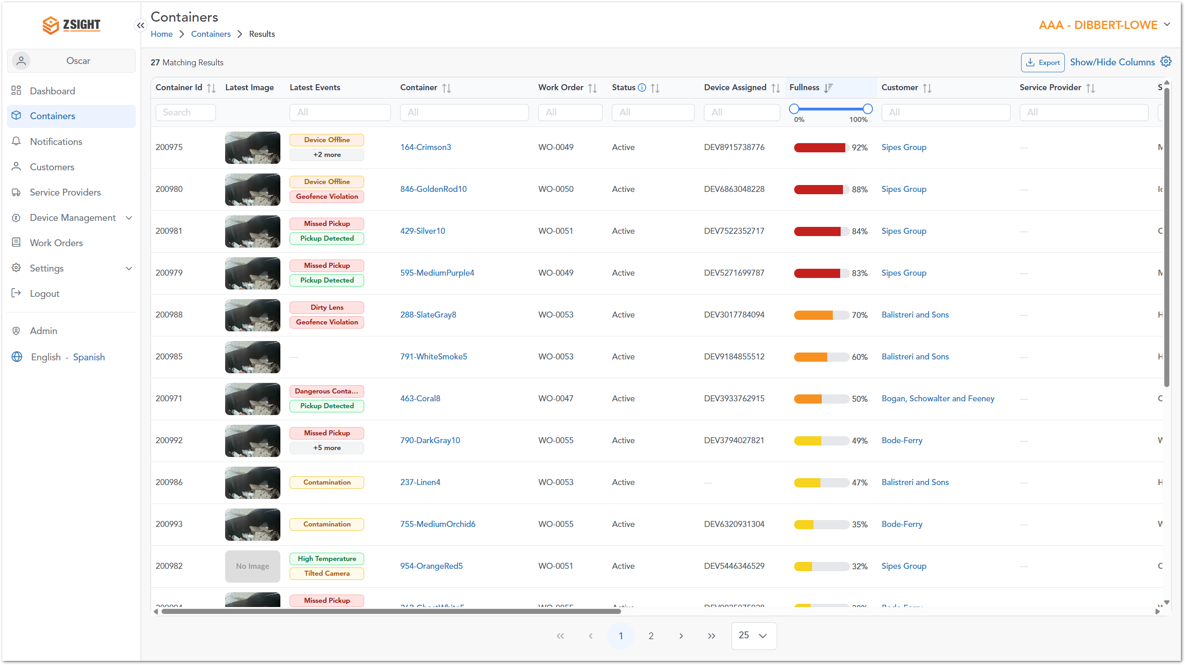

Containers List Overview
Name | Preview | Description
Container ID | 200969 | Unique numeric identifier assigned to the container. The Container ID is used throughout the system to uniquely identify each container and distinguish it from all other registered containers.
Latest Image | 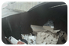 | Displays the most recent image captured by the container's camera, providing a quick visual view of its current condition and contents.
Latest Events | 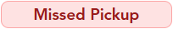  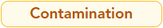  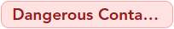  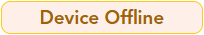  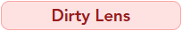  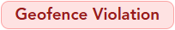  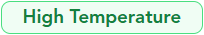  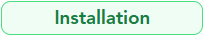  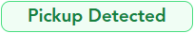  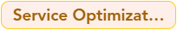  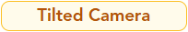 | Displays the most recent events detected for the container. Event badges provide a quick overview of operational activities, alerts, and system notifications affecting the container.  Possible Event Badges:  - Contamination: Non-allowed or mixed waste has been detected inside the container.  - Dangerous Contamination: Potentially hazardous or unsafe waste has been detected and may require special handling.  - Device Offline: The container's monitoring device is not communicating with the system.  - Dirty Lens: The camera lens may be obstructed or dirty, reducing image quality.  - Geofence Violation: The container has moved outside its expected geographical location.  - High Temperature: An abnormal temperature has been detected inside the container.  - Installation: A container or monitoring device has been installed.  - Missed Pickup: A scheduled pickup service was not completed.  - Pickup Detected: A pickup service has been successfully detected.  - Service Optimization: Indicates that the container's service schedule or frequency may benefit from optimization.  - Tilted Camera: The camera is not correctly positioned, which may affect image capture.  - +X More: Additional events are associated with the container but are not displayed in the list. Click the badge to view all events.
Container | 415-DarkSlateGray4 | Displays the container's assigned name. This human-readable identifier is used throughout ZSight to easily recognize and reference a container, while the Container ID serves as its unique system identifier.
Work Order | WO-0047 | Displays the work order associated with the container. The work order identifies the installation, maintenance, or service request related to the container and can be used to track operational activities.
Status | Active, Inactive, Created, Archived | Displays the current lifecycle status of the container. Container status is primarily managed automatically by the system as the container progresses through installation and operational workflows. Available statuses include:  - Created: The container has been registered but has not yet been installed or activated.  - Inactive: The container is currently not operating or is awaiting activation due to its current operational state.  - Active: The container is installed, operational, and actively monitored by the system.  - Archived: The container has been retired from active operations and is maintained for historical reference.
Device Assigned | DEV6150783026 | Displays the unique identifier of the monitoring device currently assigned to the container. This device collects operational data, such as fill level and events, and transmits it to ZSight for monitoring and analysis.
Fullness |  | Displays the current fill level of the container as a percentage, represented by a color-coded progress indicator to help users quickly assess the container's capacity.
Customer | Koepp-Hahn | Displays the customer associated with the container, allowing users to quickly identify the owner or organization responsible for the container.
Service Provider | Dibbert PLC | Displays the service provider currently assigned to the container. The service provider is the organization responsible for performing scheduled services, maintenance, and other operational activities associated with the container.
Site Name | Oregon Building 58162 | Displays the name of the site where the container is installed. The site name helps users quickly identify the container's associated location within a customer account.
Site Street | 24188 Jadon Alley | Displays the street address where the container is physically located. This information assists users in identifying the exact service location.
Site City | Port Minervamouth | Displays the city in which the container's service location is located.
Site State | Nebraska | Displays the state or province where the container's service location is located.
Last Service Date | Mar 19, 2026<br>Thu - 01:40:55 PM | Displays the date and time when the container was last serviced. This information helps users determine the most recent service activity performed on the container.
  Note: The Last Service Date filter uses a relative date range instead of specific calendar dates. Users can filter containers by service activity from Today, 1–6 days ago, 1–8 weeks ago, or 8+ weeks ago, making it easier to locate containers based on how recently they were serviced.
Last Service Fullness |  | Displays the fill level recorded during the container's most recent service. The value is shown as a percentage using a color-coded progress indicator.
Size (Yd) | 2, 6, 8 cubic yards | Displays the container's capacity in cubic yards (yd³). This value indicates the maximum volume of waste the container is designed to hold.
Content Type | Recycle | Displays the type of waste assigned to the container. Content types include:  - Cardboard  - Compost  - Recycle  - Trash
Service Frequency | 3x/week | Displays how often the container is scheduled to be serviced. The value indicates the number of scheduled service visits per week, and includes:  - 1x/week  - 2x/week  - 3x/week  - 4x/week  - 5x/week  - 6x/week  - 7x/week
Service Days | M/Th/F | Displays the days of the week on which the container is scheduled for service. Days are abbreviated using the following notation: M (Monday), T (Tuesday), W (Wednesday), Th (Thursday), F (Friday), S (Saturday), and Su (Sunday).

Container Details – Preview Panel
Selecting the Latest Image for a container opens the Container Details - Preview Panel on the right side of the screen. This panel provides a quick overview of the selected container, including its latest image, current fill level, service information, content composition, and recent events, allowing users to review key information without leaving the Containers page.
Key Information Displayed
- Latest update: Enlarged view of the most recent image captured inside the container.
- Current Fullness: Visual indicator showing the current fill level percentage.
- Container Information: Container name, Size (Yd), Content type, Service frequency, Last Service.
- Pickup History: Summary metrics such as average, minimum, and maximum fullness.
- Content Composition: Breakdown of waste types (e.g., trash, recyclable, organic).
- Location & Service Provider: Contact and service provider information.
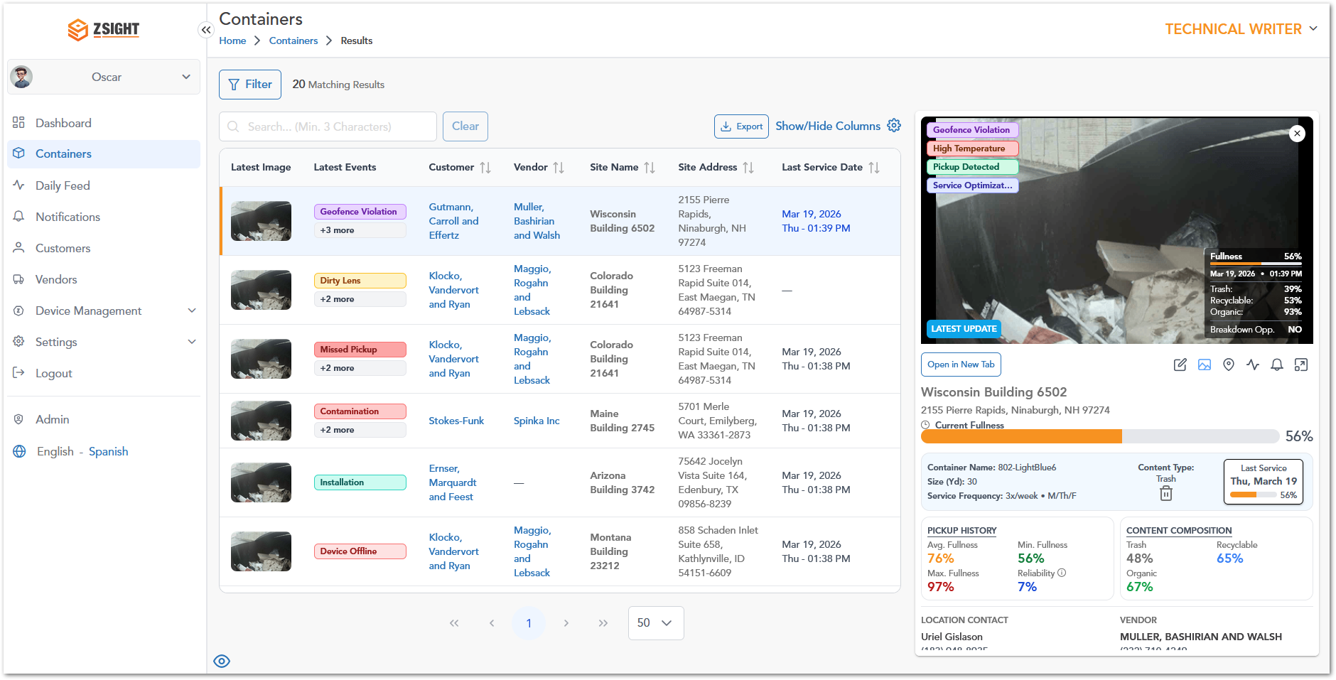

Container Details – Full View
By selecting Open in New Tab, the system opens the Container Details in a dedicated page. When scrolling down in the Container Details Full View, users can access additional operational and analytical information related to the container. This section provides deeper insights into device data, service performance, and optimization opportunities.

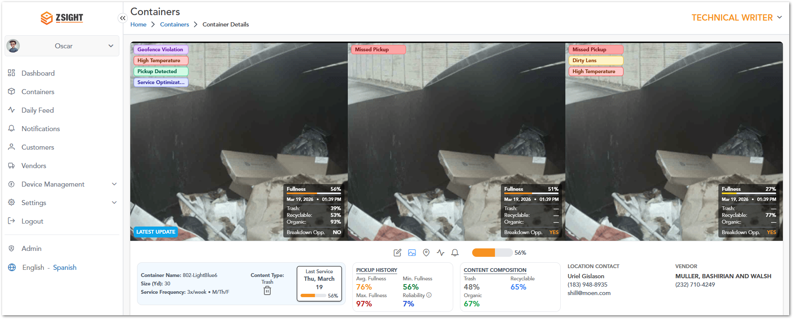
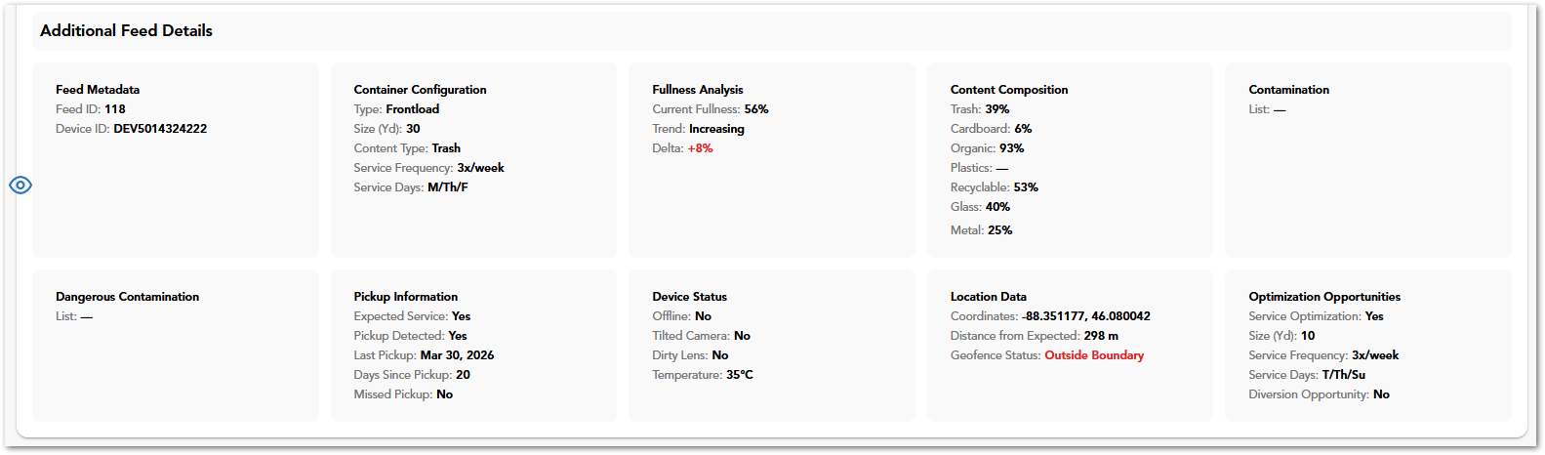
Sections Included
- Feed Metadata: Displays identification details such as Feed ID and Device ID associated with the container.
- Container Configuration: Provides configuration details including container type, size, content type, and scheduled service frequency and days.
- Fullness Analysis: Shows current fullness percentage, trend (e.g., increasing or decreasing), and variation over time.
- Content Composition: Breaks down the detected waste types (e.g., trash, recyclable, organic, glass, metal) with corresponding percentages.
- Contamination: Lists any detected contamination within the container (if applicable).
- Dangerous Contamination: Highlights any hazardous materials detected that may require special handling.
- Pickup Information: Includes service-related data such as expected service status, pickup detection, last pickup date, days since last pickup, and missed pickup indicators.
- Device Status: Displays operational status of the device, including connectivity, camera position, lens condition, and temperature.
- Location Data: Provides geolocation details such as coordinates, distance from expected location, and geofence status.
- Optimization Opportunities: Suggests potential improvements such as service optimization, recommended container size, service frequency, and diversion opportunities.

Container Details – Full View Menu
In the Container Details – Full View, users can access additional actions and views through a sub-menu located below the image section. To access these options:
- Navigate to the Containers module.
- Select a container to open the Container Details – Full View (using Open in New Tab).
- Locate the sub-menu bar positioned below the container images.
- Click on any of the available icons to switch between views or perform actions.
Name | Preview | Description
Edit container |  | Allows the user to modify container configuration details such as ID, type, size, content type and service settings.
Gallery Mode |  | This is the main page within the full view window for container details.
Map Mode |  | Shows location-related information and spatial context of the container.
Open Daily Feed |  | Redirects the user to the Daily Feed module filtered for the selected container
Open Notifications |  | Redirects the user to the Notifications module filtered for the selected container.
Container Fullness |  | Displays the current fill level of the container using a visual progress indicator.

Container Details – Full View Edit Container
The container edit option allows the user to modify container configuration details such as type, size, and service schedule.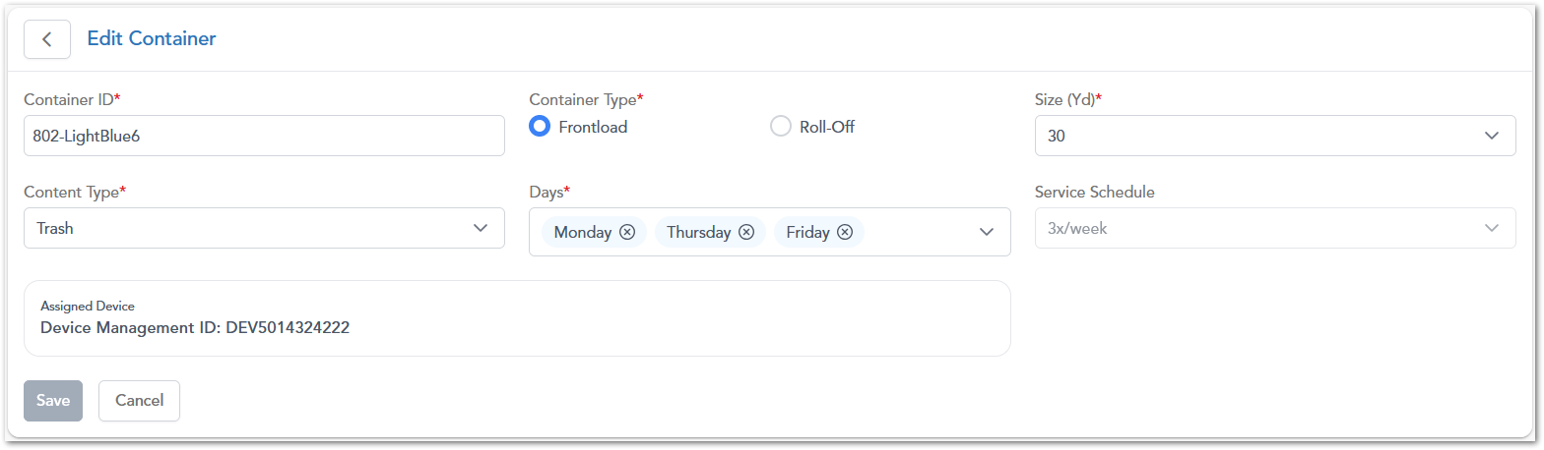

Container Details – Full View Container Location
The Location view displays the geographical position of the container on an interactive map, allowing users to visualize its placement and proximity to surrounding areas.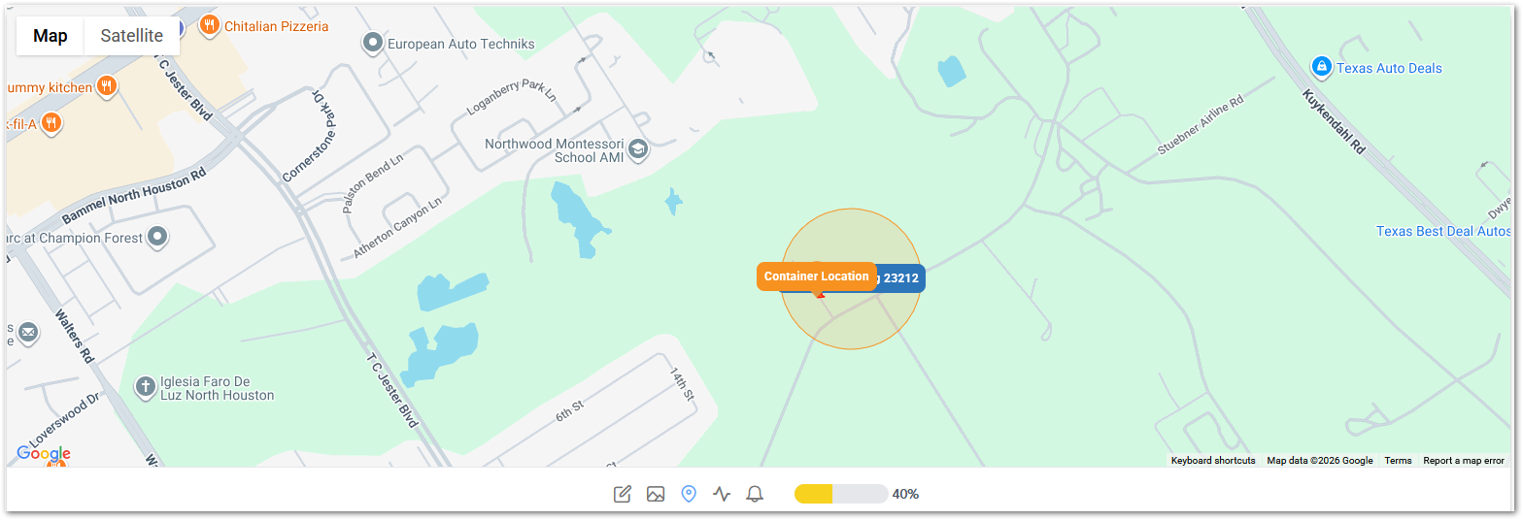

Daily Feed section
The Daily Feed displays a chronological stream of images and events captured from containers, allowing users to review recent activity and monitor changes in container status over time. The module presents information using a table structure similar to the Containers module, as it reflects the operational status of containers for a given day. Additionally, it includes extra fields related to the type of content being collected, providing more context for daily operations.
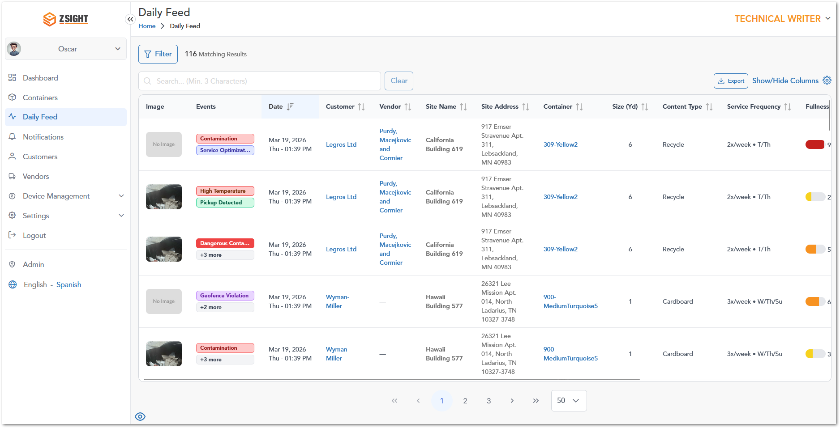

Daily Feed List Overview
Name | Preview | Description
Trash |  | Indicates the % of general (non-recyclable) waste detected inside the container.
Organic |  | Indicates the % of organic waste (e.g., food or biodegradables) inside the container.
Recyclable |  | Indicates the overall % of recyclable materials detected inside the container.
Cardboard |  | Indicates the % of recyclable cardboard material detected inside the container.
Plastics |  | Indicates the % of recyclable plastic waste detected inside the container.
Glass |  | Indicates the % of recyclable glass material detected inside the container.
Metal |  | Indicates the % of recyclable metal waste detected inside the container.

NOTIFICATIONS SECTION
The Notifications module provides a centralized view of all system-generated alerts related to monitored containers and devices. It allows users to identify active issues, review their current status, investigate the sequence of events that triggered each notification, and verify when an issue has been successfully resolved. Each notification includes contextual information and links to the related Daily Feed records, providing a complete history of the event lifecycle.
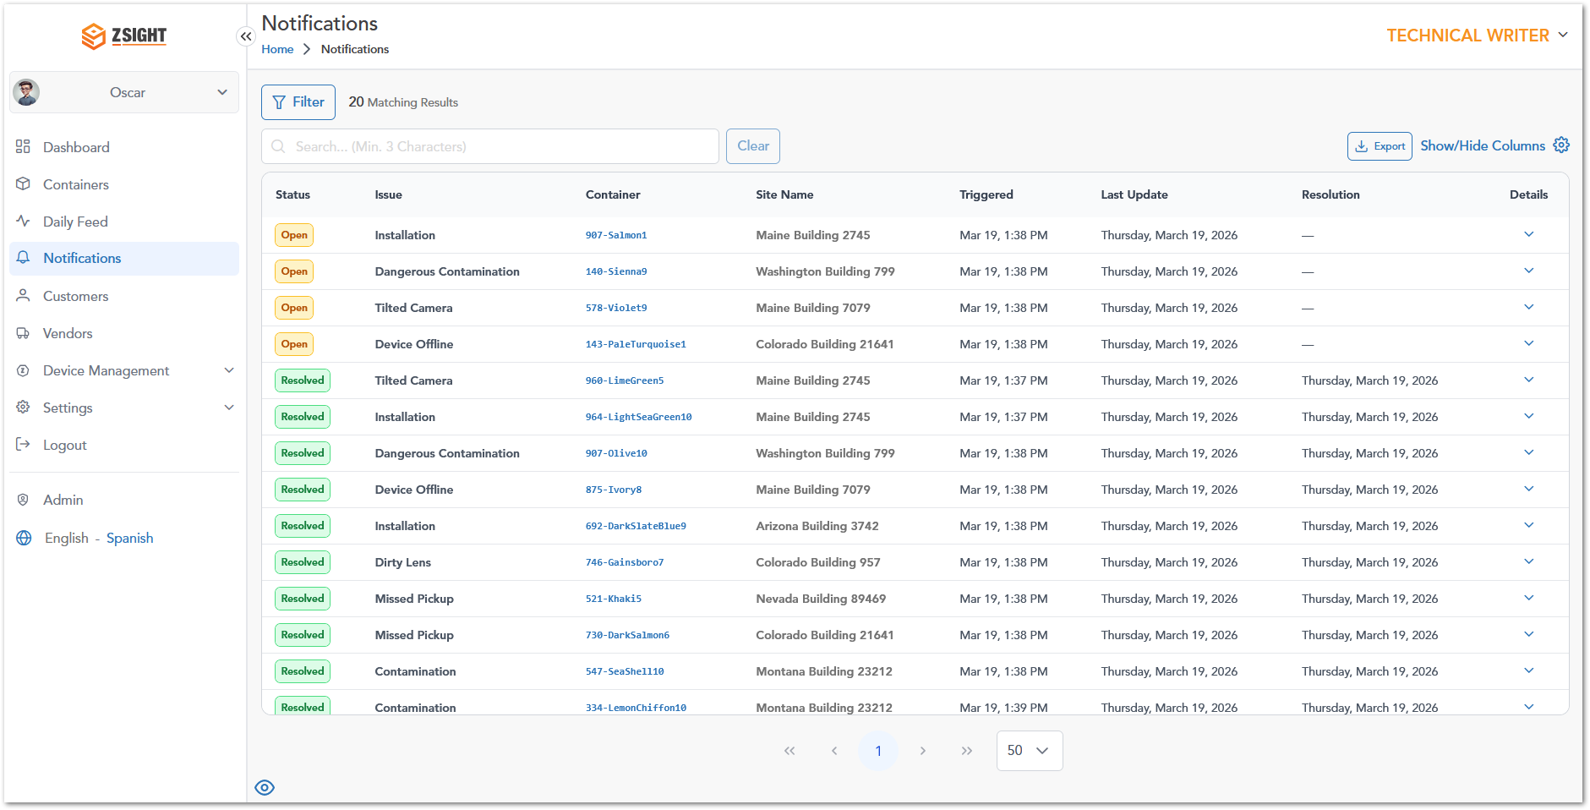

Notification Workflow
Notifications are generated automatically whenever the system detects an event that requires user attention. Each notification remains Open until the underlying issue is resolved. During its lifecycle, the notification records all related Daily Feed events, allowing users to review how the issue evolved over time. A typical notification lifecycle is:
- An event is detected by the system.
- A notification is automatically created.
- The notification remains in the Open state while the issue is active.
- Related Daily Feed events are linked to the notification as additional images are processed.
- Once the issue is resolved, the notification status changes to Resolved, preserving the complete event history.

Name | Preview | Description
Status | 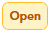  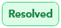 | Indicates the current lifecycle state of the notification:  - Open – The detected issue is still active and requires attention.  - Resolved – The issue has been successfully addressed and closed.
Issue | Installation | Type of event or problem detected (e.g., contamination, device offline).
Container | 907-Salmon1 | Identifier of the container associated with the notification.
Site Name | Maine Building 2745 | Location where the container is installed.
Triggered | Mar 19, 1:38 PM | Date and time when the notification was generated.
Last Update | Thursday, March 19, 2026 | Most recent update related to the notification.
Resolution | Thursday, March 19, 2026 | Date when the issue was resolved (only resolved issues have dates).
Details | Koepp-Hahn | Expandable option to view additional information.

Note: The available columns may vary depending on future system updates or user permissions. Users can customize the visible columns using the Show/Hide Columns option.

Selecting the Details option expands a notification to display additional information about the detected issue. The information presented depends on the notification status. Active notifications focus on the ongoing event and its progression, while resolved notifications also include installation and device information collected during the notification lifecycle.

Notifications – Open Issue Details
When an Open notification is expanded, the system displays additional information to help users investigate the active issue. The expanded view includes:
- The number of days since the issue was first detected.
- Linked Daily Feed records associated with the notification.
- The chronological sequence of captured events.
- Event timestamps.
- Fullness measurements recorded for each capture.
- Event labels indicating how the notification evolved (for example, Trigger).
This information helps users understand the progression of the issue and determine whether additional action is required.
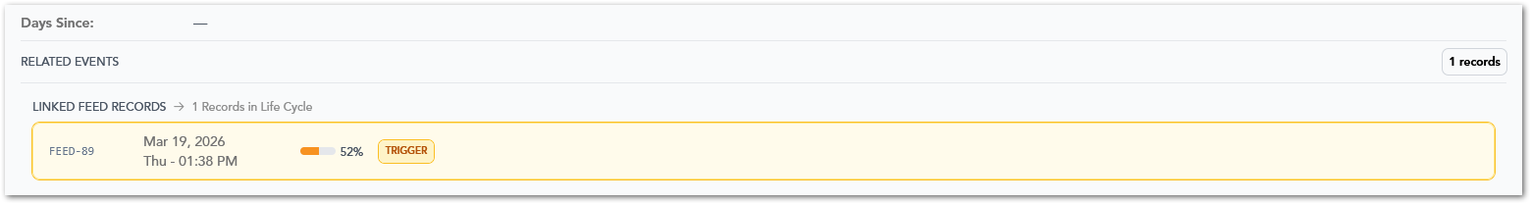

Notifications – Resolved Issue Details
When a Resolved notification is expanded, the system displays the complete history of the issue, including both the original event and its successful resolution. In addition to the linked Daily Feed records, the expanded view includes:
- Installation date.
- Intended device serial number.
- Actual device serial number.
- Number of days since the notification was triggered.
- Chronological history of all related events.
- Trigger and Resolution event markers.
- Fullness measurements captured during the notification lifecycle.
This information provides a complete audit trail of the notification, allowing users to review how the issue was detected, monitored, and ultimately resolved.
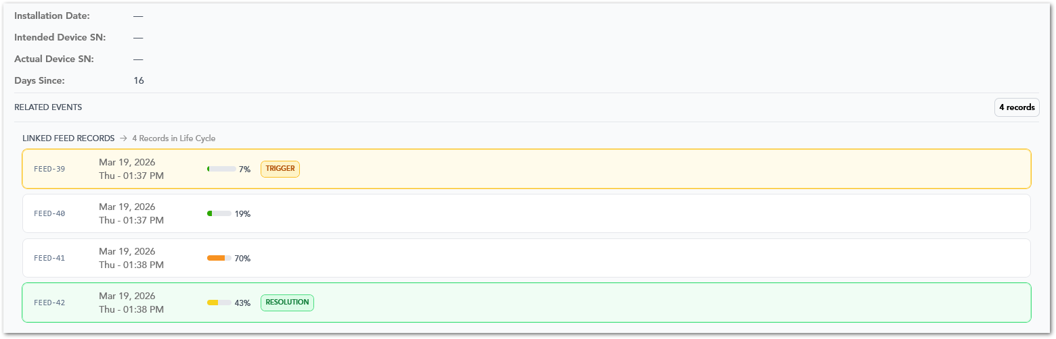
Tip: When investigating an issue, review the Linked Feed Records in chronological order. This provides the complete sequence of images and events captured before and after the notification was generated, making it easier to understand how the issue developed.

CUSTOMERS SECTION
The Customers module provides a centralized view of all customers managed within the system, allowing users to access, monitor, and maintain customer-related information. From this module, users can review key operational data such as service locations, assigned containers, contact details, account ownership, and customer status.
It also enables efficient data management through search, filtering, sorting, column customization, and export functionalities, supporting both day-to-day operations and reporting needs.

Customers List Overview
Name | Description
Customer Name | Displays the name of the customer; clickable to access detailed customer information.
Customer ID | Unique identifier assigned to each customer in the system.
Service Locations | Indicates the number of service locations associated with the customer.
Containers | Shows the total number of containers assigned to the customer.
Contact Name | Name of the primary contact for the customer account.
Contact Phone Number | Phone number of the primary contact.
Contact Email | Email address of the primary contact.
Account Manager | Account manager responsible for managing the customer account.
Date Added | Date when the customer was created in the system.
Status | Indicates whether the customer is active or inactive.
Actions | Provides available actions for the record, such as editing the customer.

SERVICE PROVIDERS SECTION
The Sevice Providers module provides a centralized view of all service providers associated with the system, allowing users to manage service provider-related information and monitor their operational involvement. From this module, users can review key details such as service provider contact information, service coverage, associated containers, and optimization activity.
It also supports efficient data management through search, sorting, column customization, and export functionalities, enabling users to easily access and maintain service provider records.

Service Providers List Overview
Name | Description
Service Provider Name | Displays the name of the service provider; clickable to access detailed service provider information.
Service Provider ID | Unique identifier assigned to each service provider in the system.
Address | Physical address associated with the service provider.
Contact Phone Number | Phone number of the service provider’s primary contact.
Contact Email | Email address of the service provider’s primary contact.
# Containers | Indicates the number of containers associated with the service provider.
# Service Optimization | Shows the number of service optimization instances related to the service provider.
Actions | Provides available actions for the record, such as editing the service provider.

DEVICE MANAGEMENT SECTION
The Device Management module provides a centralized view of all monitoring devices assigned to the selected account. A device is the camera unit installed in a container, identified by its serial number. From this module, users can review device information, link devices to containers, and turn devices on or off remotely.
Devices are registered in ZSight automatically when the hardware provider ships them, so serial numbers do not need to be entered manually. Devices assigned to an account appear in that account's Device Management list.
Note: Administrators can view and manage devices across all accounts from Admin > Inventory. For more information, see the Inventory section.

Devices List Overview
The Devices list displays every device assigned to the selected account, together with its current mode, the last command sent to it, and the container and customer it is linked to. Use this list to locate a device, check its status, and open its details.
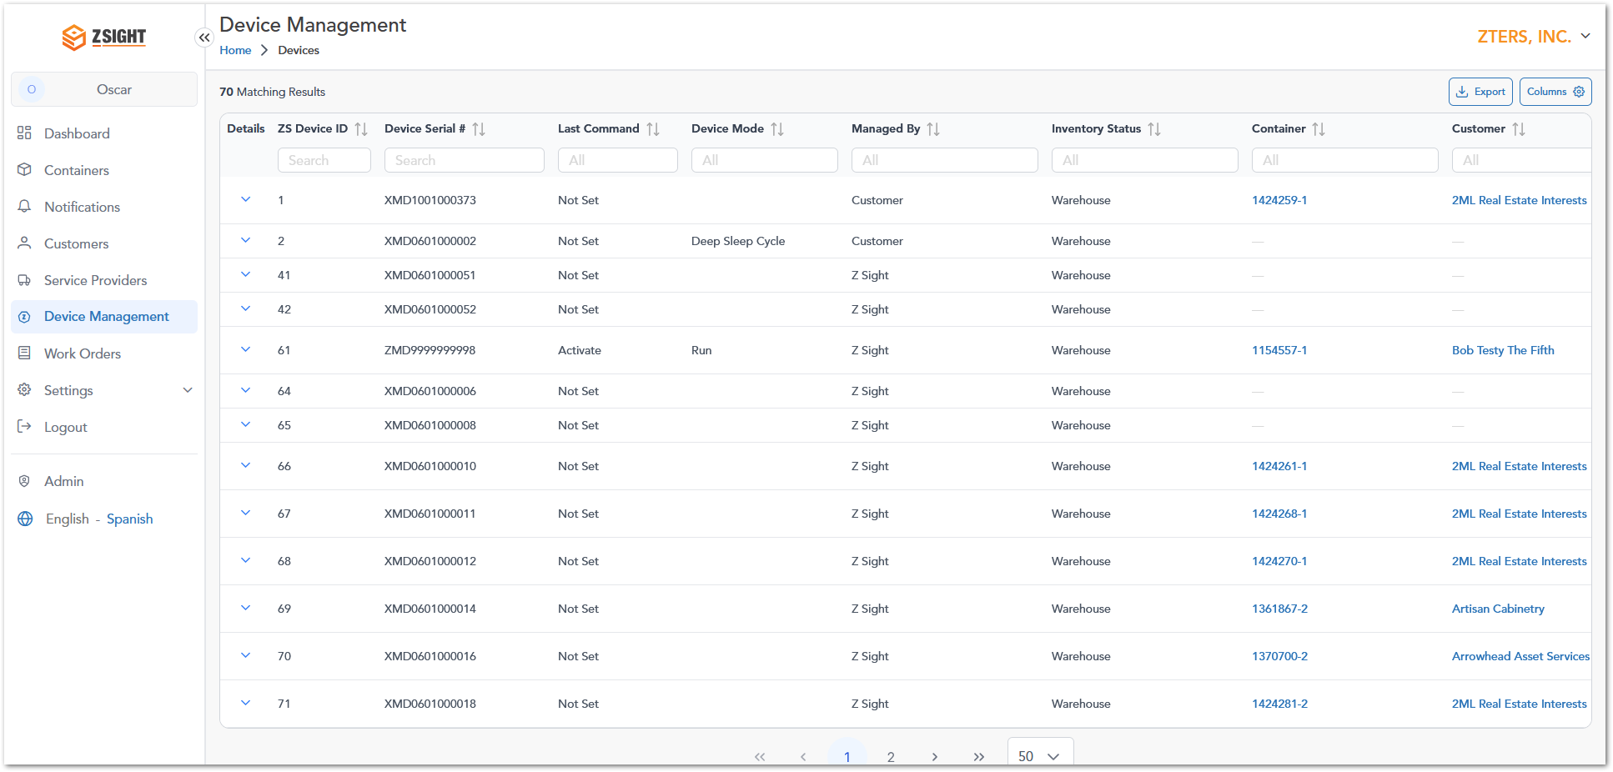

Name | Description
Details | Expands the row to show the device details and available commands
ZS Device ID | Unique identifier assigned to the device record in ZSight
Device Serial # | Manufacturer serial number used to identify the physical device
Last command | Most recent command sent to the device from ZSight: Link, Unlink, Re-link, Activate or Deactivate. Displays Not Set when no command has been sent from ZSight
Device Mode | Current operating mode reported by the device, such as Run (active and capturing images) or Deep Sleep Cycle (inactive). The field is blank when the device has not reported a mode
Managed By | Indicates who manages the device. Values observed: Customer, ZSight
Inventory Status | Indicates the inventory status of the device. Value observed: Warehouse
Container | The container that the device is linked to. Displays a dash (—) when the device is not linked to any container. Select the value to open the container
Customer | Customer that owns the linked container. Displays a dash (—) when the device is not linked to any container. Select the value to open the customer

Note: Last Command and Device Mode are independent. Devices that were already running before commands were introduced may show Not Set in Last Command while Device Mode shows Run.

Info: Search, filtering, export and column customization work as described in the Overall System Functionalities section.

Device Details
The device details provide more information about a selected device and let users send it commands. To open them, click the arrow in the Details column. The details expand directly below the device’s row, and clicking the arrow again collapses them.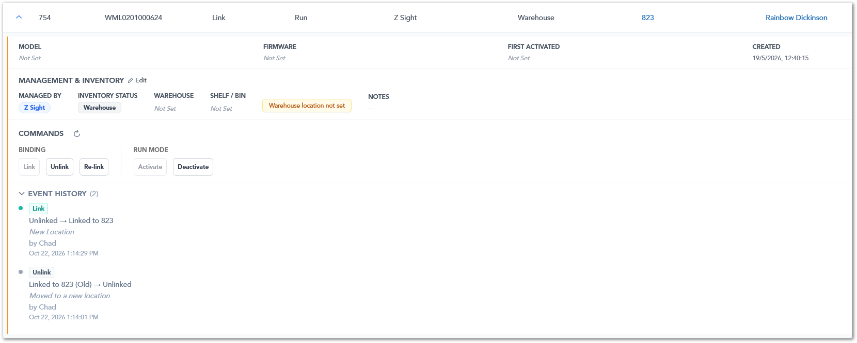
The details are organized into four areas: Device Information, Management & Inventory, Commands, and Event History.

Device Information
The top of the details panel shows general information about the device hardware and when the device was registered in ZSight.
Name | Description
Model | Hardware model of the device
Firmware | Firmware version installed on the device
First Activated | Date the device was first activated
Created | Date and time the device was registered in ZSight

Note: Fields that do not have a value display Not Set.

Management & Inventory
The Management & Inventory area shows who manages the device and where it is stored. Select Edit next to the area title to update this information.
Name | Description
Managed By | Indicates who manages the device, such as ZSight or Customer
Inventory Status | Indicates the inventory status of the device, such as Warehouse
Warehouse | Warehouse where the device is stored
Shelf / Bin | Shelf or bin location of the device within the warehouse
Notes | Additional notes about the device

Info: When a device's inventory status is Warehouse and no warehouse has been entered, the message Warehouse location not set is displayed.

Commands
The Commands area contains the buttons used to send commands to the device. The buttons are grouped into Binding (Link, Unlink, Re-link) and Run Mode (Activate, Deactivate). Only the commands that apply to the device's current state can be selected; the others are grayed out.
For example, a device that is linked to a container and was last activated can be Unlinked, Re-linked or Deactivated, while Link and Activate are grayed out.
Click the refresh icon next to Commands to update the area and check whether a pending command has been confirmed. For a description of each command, see Device Commands.

Event History
The Event History is a record of the commands sent to the device, shown with the most recent first. The number next to the title shows how many events are recorded. Click the title to expand or collapse the list.
Each event shows:
- Command: the command that was sent, such as Link or Unlink.
- Change: the device's state before and after the command, for example Unlinked → Linked to 823. When a device is unlinked or re-linked, the container it was previously linked to is marked (Old).
- Note: the note or reason entered when the command was sent, if any.
- User: the user who sent the command.
- Date and time: when the command was sent.
Failed and expired commands are also listed. They are shown as attempts, because the change was never applied. Reasons and notes are kept only in ZSight; they are not sent to the device.

Device Commands
Commands let users manage a device remotely, without visiting the container. Each command is relayed to the physical device and takes effect only after the device confirms it. Commands fall into two independent groups:
- Binding commands control which container the device is linked to.
- Run mode commands turn the device on or off.
Linking a device to a container does not turn it on, and turning a device on does not link it to a container. Each must be done separately.
Info: An active device takes images and reports to ZSight even when it is not linked to a container. Data from a device that is not linked to a container is visible only to ZTERS administrators, from Admin > Inventory.

Binding Commands
Binding commands pair a device with a container, remove that pairing, or move the device to a different container. They are usually confirmed within a few seconds.
Command | Available when | Description
Link | The device is not linked to any container. | Links the device to a container. The selection list shows only containers that do not already have a device. A note can be added.
Unlink | The device is linked to a container. | Removes the link between the device and its current container. The device keeps its run mode: if it is active, it continues to capture images. A note can be added.
Re-link | The device is linked to a container. | Moves the device from its current container to a different one in a single step, without the device ever appearing as unlinked. A reason is required, and notes can be added.

When re-linking a device, select one of the following reasons:
Reason | When to use it
Tenant change | The customer associated with the container has changed.
Provider change (customer-owned) | The service provider has changed, and the container is owned by the customer.
Other | Any other reason. A short explanation must be entered.

Note: Fields that do not have a value display Not Set.

Run Mode Commands
Run mode commands control whether the device is active. An active device captures images and sends data to ZSight; a sleeping device stops capturing images and sending data.
Command | Available when | Description
Activate | The device has never been activated from ZSight, or its last run mode command was Deactivate. | Turns the device on.
Deactivate | The device's last run mode command was Activate. | Puts the device to sleep. The device stays asleep until it is activated again. A reason is required.

When deactivating a device, select one of the following reasons:
Reason | When to use it
Uninstall | The device is being removed from the container
Swap container | The container is being replaced with a different one
Container modification | The container is being modified.
Provider change | The service provider of the container is changing
Damage | The device is damaged
Other | Any other reason. A short explanation must be entered

Note: A device that has never received a run mode command from ZSight can be activated, but not deactivated.

Warning: Activate and Deactivate do not take effect immediately. The device receives the command the next time it connects, which can take up to 9 hours, or longer if the device is in deep sleep. If the device does not confirm the command within 24 hours, the command expires, the device stays as it was, and the command can be sent again.

Command Status
Every command goes through the same stages. The device and its container change only when the command is confirmed.
Status | Meaning
Pending | The command has been sent and is waiting for confirmation. Nothing has changed yet.
Confirmed | The device confirmed the command, and the change was applied.
Failed | The command could not be applied. Nothing changed, ZSight shows the reason, and the command can be sent again.
Expired | No confirmation was received in time: 24 hours for run mode commands, 60 minutes for binding commands. Nothing changed, and the command can be sent again.

Note: A device can have only one pending command of each group at a time. For example, while a Link is pending, Unlink and Re-link cannot be sent, but Activate can. A container can also be the target of only one pending command at a time.

Info: Device Mode shows what the device itself reports, so it may take some time to change after a run mode command is confirmed.

How to Send a Command
All commands are sent from the Commands area of the device details. Commands that do not apply to the device's current state are grayed out.
- Navigate to Device Management.
- Click the arrow in the Details column of the device.
- In the Commands area, click the command you want to send.
- For Link or Re-link, select the target container.
- Select a reason, if required, and enter any notes.
- Confirm to send the command.
If a command cannot be sent, ZSight displays a message explaining why, for example, that the selected container already has a device. Every command, including failed and expired ones, is recorded in the Event History.

WORK ORDERS SECTION
The Work Orders module provides a centralized view of container installation work orders within ZSight. Work orders are used to track installation activities and monitor the lifecycle of container associated with a specific installation request.
This module allows users to review work order information, including access code, creation dates, and the number of containers created, active, inactive, or archived under each work order. Work orders serve as a link between installation activities and the containers deployed in the field.
Note: Containers created through a Work Order become available in the Containers module, where users can monitor fullness levels, service activity, images, notifications, and operational metrics.

Work Orders List Overview
The Work Orders page displays all work orders available to the selected accounts.
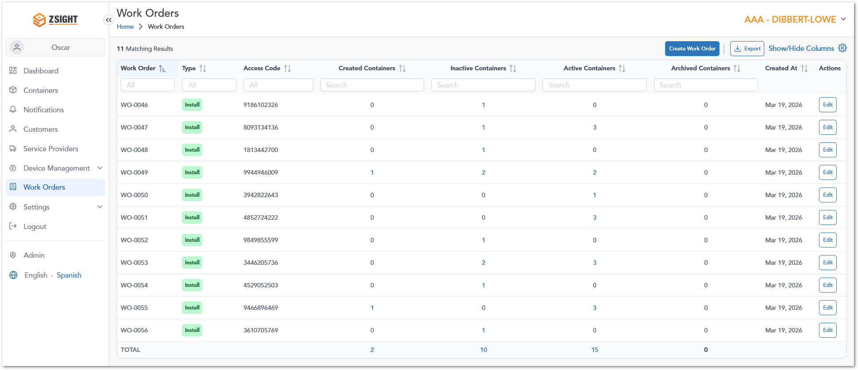

Name | Description
Work Order | Unique identifier assigned to the work order.
Type | Indicates the type of work order being tracked.
Access Code | Unique code associated with the work order installation process.
Created Containers | Number of containers created under the work order.
Inactive Containers | Number of containers currently marked as inactive.
Active Containers | Number of containers currently active and reporting data.
Archived Containers | Number of containers archived under the work order.
Created At | Date when the work order was created.

Available Actions
The Work Orders module supports several common system functions:
- Search: Locate work orders using available search fields.
- Filter: Narrow results using the column filters displayed at the top of the table.
- Export: Download the work order information displayed, to a spreadsheet file.
- Show/Hide Columns: Customize which columns are visible in the table.
- Sorting: Sort records by clicking the “sort” icon available in supported columns.
- Create Work Order: Creates a new installation work order by providing a valid Access Code.
- Edit: Opens the selected work order and allows the Access Code to be updated or the work order to be removed.

Work Order and Container Relationship
Each work order can be associated with one or more containers. The container counters displayed in the Work Order table provide a quick summary of the deployment status of containers associated with that work order:
- Created Containers represent newly created container records.
- Active Containers represent containers currently active within the system.
- Inactive Containers represent containers that are temporarily inactive.
- Archived Containers represent containers that have been archived and are no longer actively monitored.
Users can use these counts to quickly assess the status of deployments and identify work orders that may require additional attention.

Create Work Order
The Create Work Order function allows users to create a new installation work order within the selected account. To create a work order:
- Navigate to Work Orders.
- Click Create Work Order.
- Enter the required Access Code.
- Click Save.
Once created, the work order becomes available on the Work Order list and can be used to associate containers with the installation activity.
Note: The Access Code is a required field and is used to identify the installation work order.

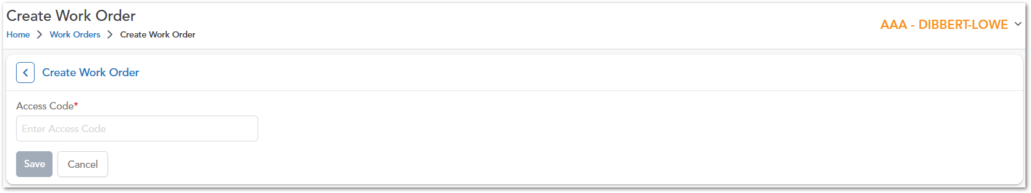

Edit Work Order
The Edit Work Order function allows users to modify the Access Code associated with an existing work order. The edit a work order:
- Navigate to Work Orders.
- Locate the desired work order.
- Click Edit in the Actions column.
- Update the Access Code as required.
- Click Save.
Changes are applied immediately after saving.
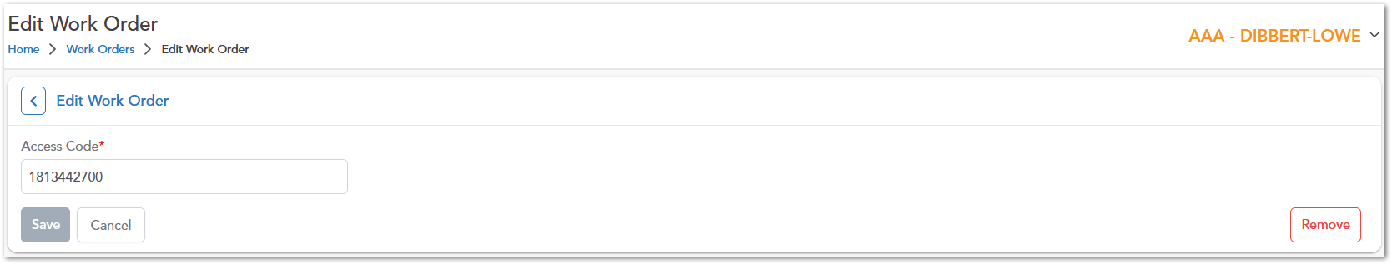

Remove Work Order
Users can permanently remove an existing work order from the system. To remove a work order:
- Open the Edit Work Order page.
- Click Remove.
- Confirm the action when prompted.
Warning: Removing a work order may affect any containers or installation records associated with that work order. Verify that the work order is no longer required before removing it.

SETTINGS
The Settings module allows users to manage personal preferences, account configurations, and team-related information within the system. It provides access to profile details, account settings, and user management functionalities, ensuring that users can maintain accurate information and control their working environment.

My Profile Overview
The My Profile section allows users to view and update their personal information and preferences within the system. It enables users to maintain accurate contact details, manage login credentials, and configure language and timezone settings.
Name | Description
First Name | User’s first name.
Last Name | User’s last name.
Email | User’s registered email address used for login.
Preferred Language | Language preference for the application interface.
Password | Allows the user to update their account password.
Confirm Password | Field to confirm the new password entered.
Voice Number | User’s primary contact phone number.
SMS Text Number | Phone number used for receiving SMS notifications.

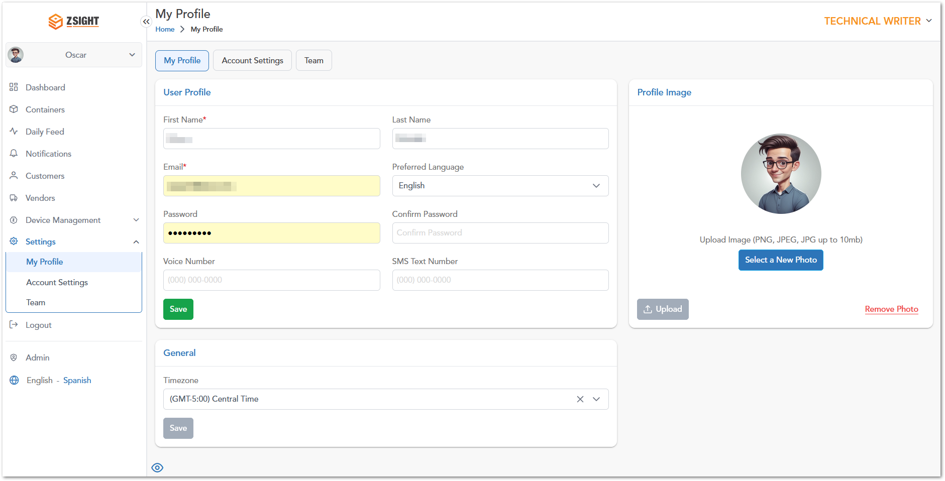

Account Settings
The Account Settings section allows users to view and manage account-level information, including general account details, contact management, and communication preferences. This section ensures that account data remains accurate and that users can control how communications are received.
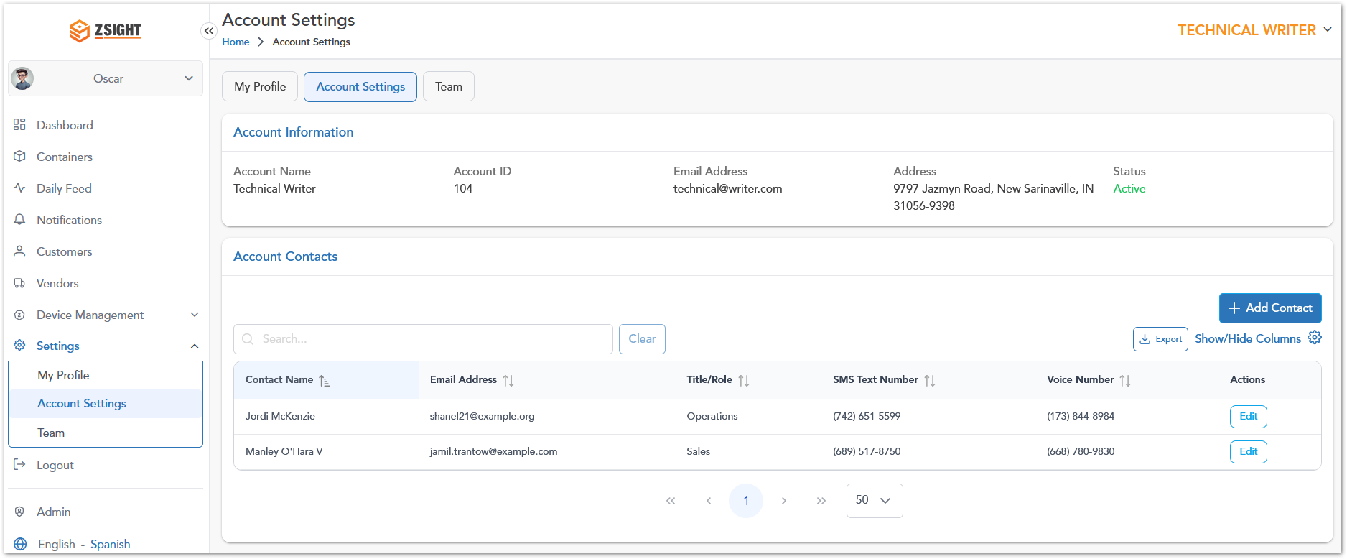

Team
The Team section allows users to view and manage all users associated with the account. It provides visibility into user roles, activity, and access status, enabling effective management of account members and permissions.
Name | Description
User Name | Displays the name of the user associated with the account.
Email | Email address of the user, used for login and communication.
Role | Defines the user’s level of access within the system (e.g., Account Owner, Admin, User).
Registration Date | Date and time when the user was added to the account.
Last Login Date | Most recent date and time the user accessed the system.
Status | Indicates whether the user is active or inactive.
Actions | Provides available options to manage the user (e.g., edit or update access).

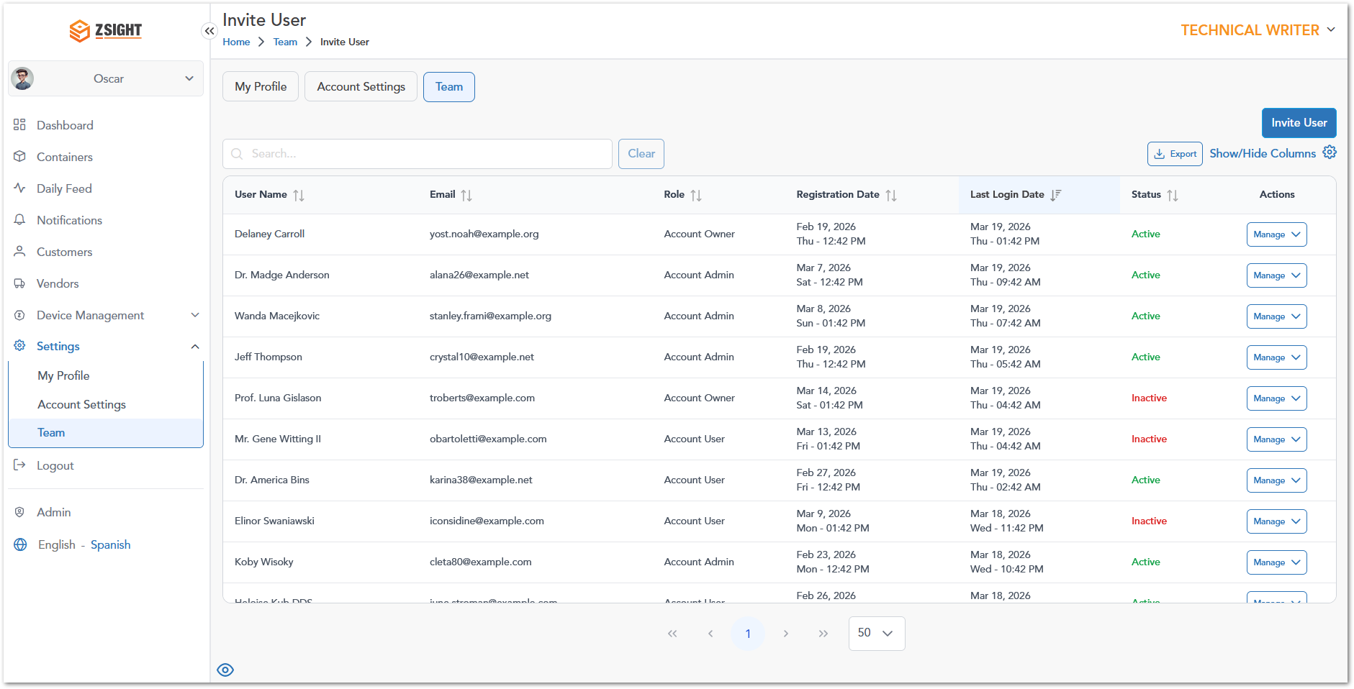

ADMIN OPTIONS
The Admin section provides access to advanced system management features intended for administrative users. It allows centralized control over core system entities such as accounts, users, customers, contracts, subscriptions, inventory, and reporting.
This section is designed to support configuration, monitoring, and maintenance activities across the platform, enabling administrators to manage system data, oversee operations, and ensure proper system governance.

Available modules
The Admin section includes the following modules:
- Admin Dashboard: Provides an overview of system activity and key metrics.
- Accounts: Manages customer accounts and their associated information.
- Customers: Provides access to customer records within the admin scope.
- Users: Allows management of user accounts and permissions.
- Contracts: Handles contract-related data and configurations.
- Subscriptions: Manages subscription plans and service agreements.
- Inventory: Tracks and manages system assets and resources.
- Installers: Manages installer-related information and assignments.
- Reports: Provides access to system-generated reports and analytics.
- Audit Trail: Tracks system activity and changes for traceability.
Note: Access to the Admin section is typically restricted to users with elevated permissions, as it contains system-wide configuration and management functionalities.

Admin Dashboard
The Admin Dashboard provides a high-level overview of system activity and key operational metrics for administrative users. It is intended to offer visibility into overall platform performance and support monitoring and decision-making at a system-wide level.

Accounts
The Accounts module allows administrators to view and manage all accounts registered within ZSight. It provides a centralized view of account information, including account identifiers, contact details, status, and administrative actions.
Administrators can access account-specific dashboards, update account information, and monitor account activity through a single interface. Each account serves as an organizational entity that groups customers, users, containers, and other operational data within the platform.
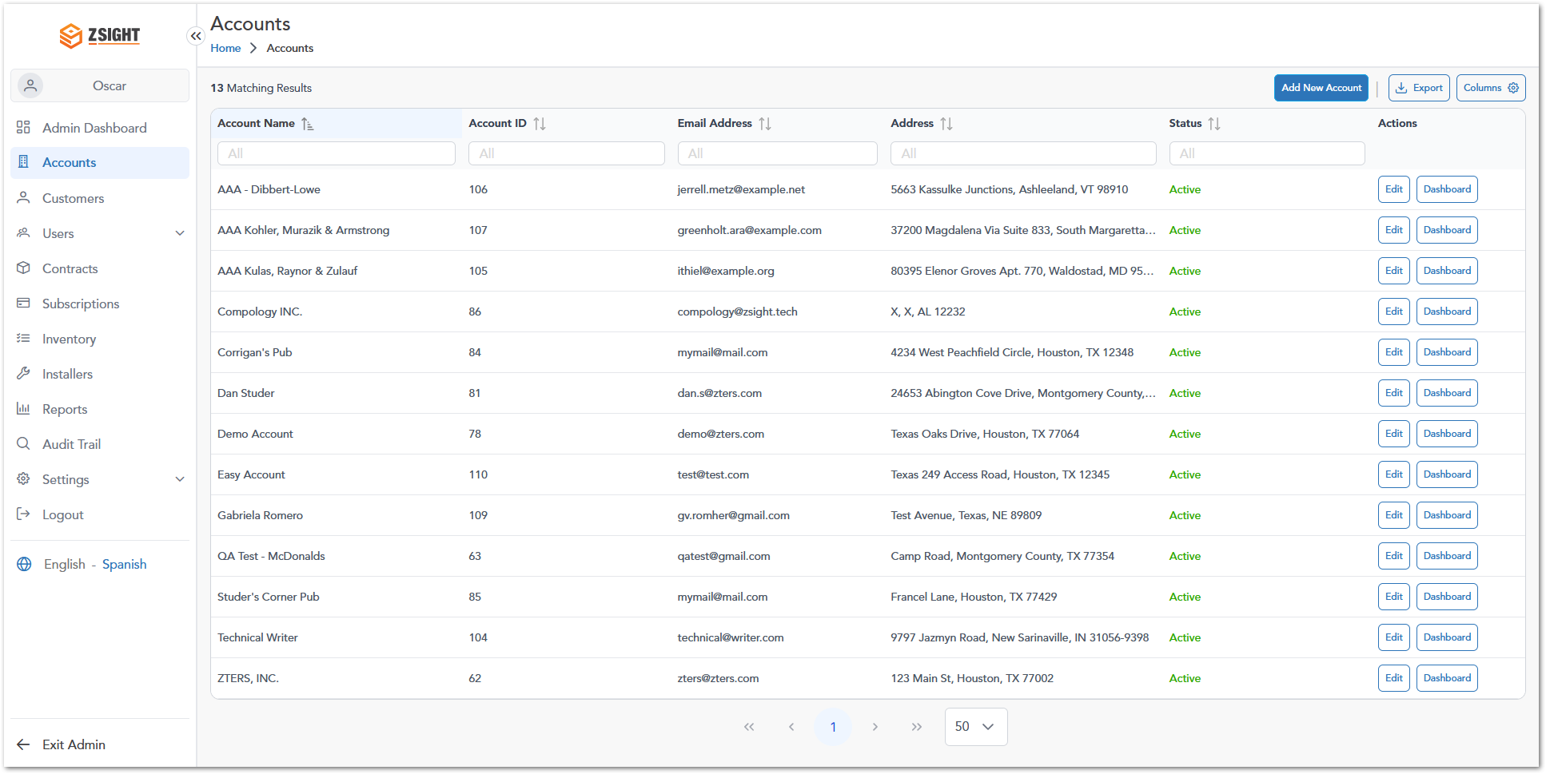
Name | Description
Account Name | Displays the name of the account. Selecting an account name opens the corresponding account record and provides access to additional account information.
Account ID | Unique identifier assigned to the account. The Account ID is used internally by the system to distinguish accounts and maintain data relationships.
Email Address | Primary email address associated with the account. This email may be used for administrative communications and account-related notifications.
Address | Physical address associated with the account, including street, city, state, and postal code information.
Status | Indicates the current status of the account. Available values:  - Active: The account is enabled and can access associated ZSight functionality.  - Inactive: The account is disabled and may have restricted access to system functionality.
Actions | Provides administrative actions that can be performed on the account. Available actions include:  - Edit: Opens the account record to modify account information.  - Dashboard: Opens the account-specific dashboard containing operational and analytical information related to the selected account.

Note: Accounts represent the highest organizational level within ZSight. Other entities such as customers, users, containers, work orders, and service providers are associated with a specific account.

Edit Account
The Edit Account page allows administrators to update account information and maintain account contact details. Changes made in this page are applied to the selected account and may affect how account information is displayed throughout the platform.
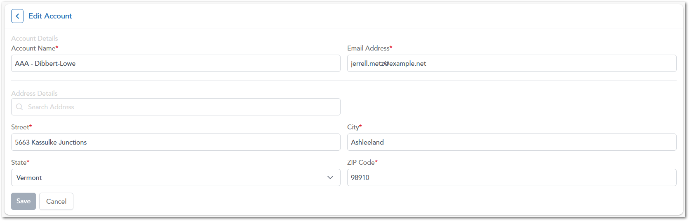
The following information can be modified:
Field | Description
Account Name | Name of the account displayed throughout the system.
Email Address | Primary email address associated with the account.
Street | Street address associated with the account.
City | City associated with the account address.
State | State associated with the account address.
ZIP Code | Postal code associated with the account address.
To update an account:
- Navigate to Admin > Accounts.
- Locate the desired account.
- Select Edit from the Actions column.
- Modify the required information.
- Select Save to apply the changes.
Note: Fields marked with an asterisk (*) are required and must contain valid information.

Customers
The Customers module allows administrators to view and manage customer records across the platform. It provides a centralized view of customer information, including customer identifiers, account associations, and primary contact details.
Administrators can use this module to maintain accurate customer information, manage customer-account relationships, and access customer records for administrative and operational purposes. Each customer is associated with an account and serves as a key organizational entity within the ZSight platform.
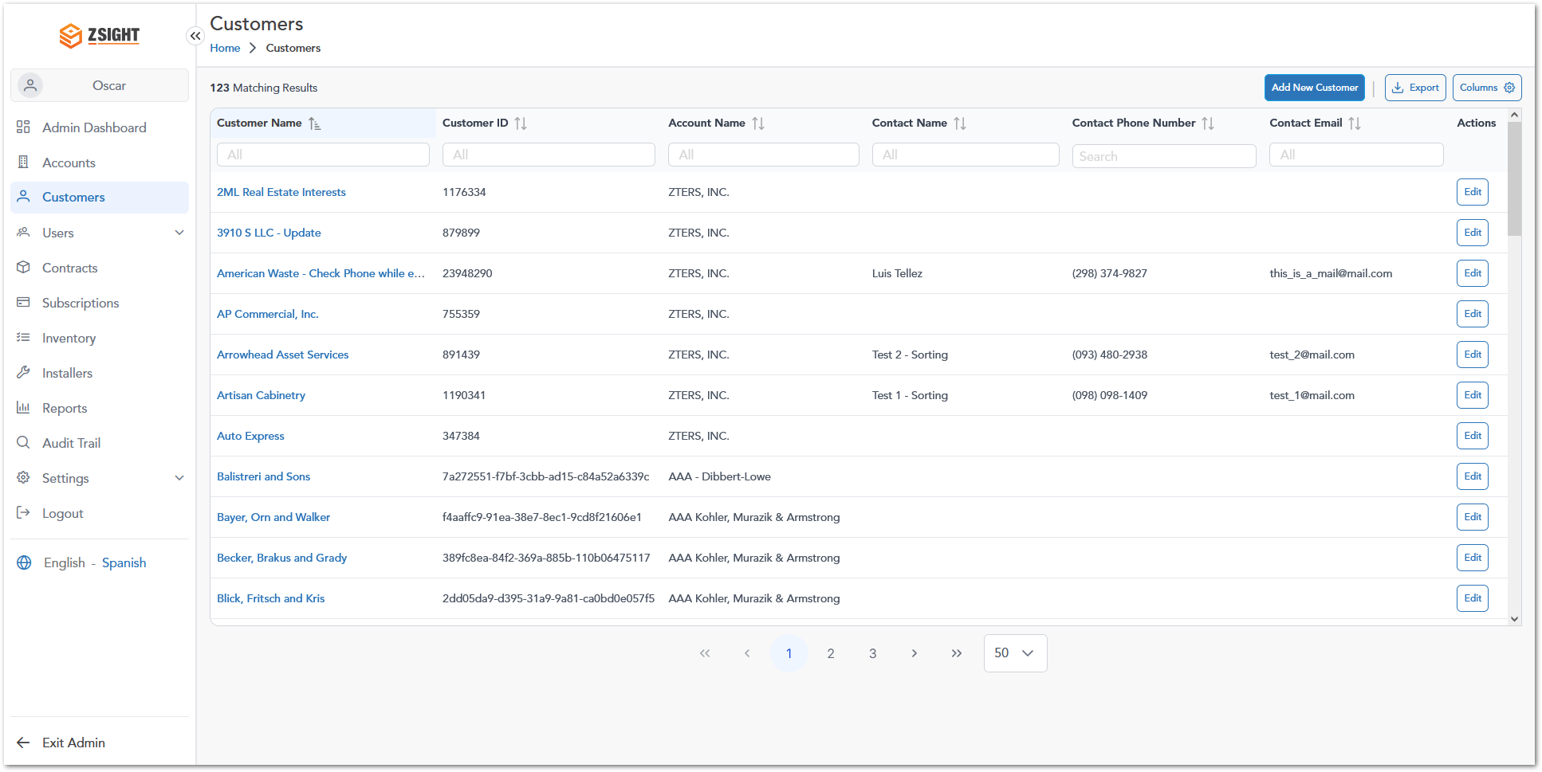
Name | Description
Customer Name | Displays the customer name. Selecting the customer name opens the customer record and provides access to additional customer information.
Customer ID | Unique identifier assigned to the customer. This identifier is used internally by the system to distinguish customer record and maintain data relationships across the platform.
Account Name | Display the account to which the customer belongs. Customer records are organized and managed within their associated account.
Contact Name | Displays the primary contact associated with the customer record.
Contact Phone Number | Displays the phone number associated with the primary customer contact.
Contact Email | Displays the email address associated with the primary customer contact.
Actions | Provides administrative actions that can be performed on the customer record. Available actions include editing customer information.

Create Customer
The Add New Customer page allows administrators to create customer records and associate them with an existing account. Customer records store contact information and account relationships used throughout the platform.
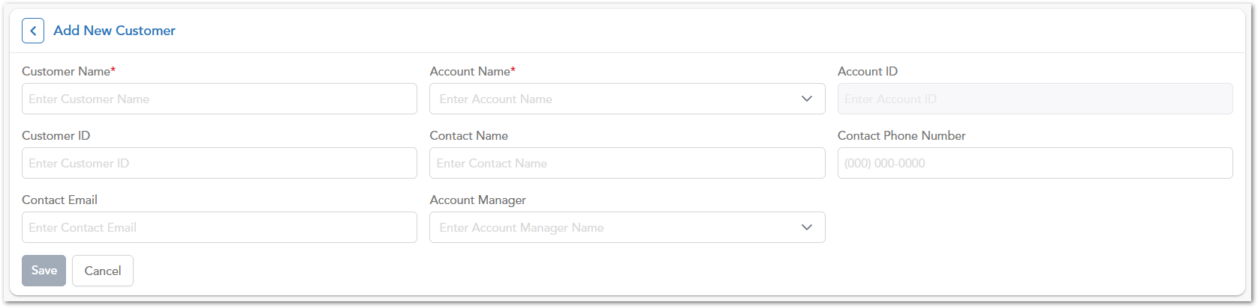
Field | Description
Customer Name | Name displayed for the customer throughout the platform.
Account Name | Account associated with the customer. Customer must belong to an account.
Account ID | Unique identifier of the associated account. This field is displayed for reference purposes.
Customer ID | Unique identifier assigned to the customer record.
Contact Name | Name of the primary contact associated with the customer.
Contact Phone Number | Phone number of the primary customer contact.
Contact Email | Email address of the primary customer contact.
Account Manager | User assigned as the account manager for the customer.

To create a new customer record:
- Navigate to Admin > Customers.
- Select Add New Customer.
- Enter the required customer information.
- Select the appropriate Account Name.
- Complete the contact information fields as needed.
- Assign an Account Manager if applicable.
- Select Save to create the customer record.
Note: Fields marked with an asterisk (*) are required and must contain valid information before the customer record can be created.

Edit Customer
The Edit Customer page allows administrators to update customer information, manage account associations, and maintain primary contact details. Administrators can access this page by selecting Edit from the Actions column in the Customers module.
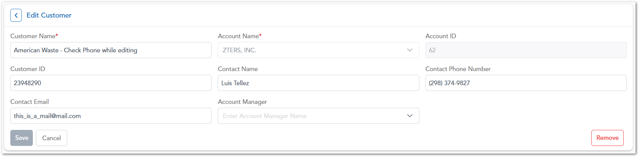
To modify an existing customer:
- Navigate to Admin > Customers.
- Locate the desired customer record.
- Select Edit from the Actions column.
- Update the required customer information.
- Select Save to apply the changes.
Warning: The Edit Customer page uses the same fields available during customer creation and allows administrators to update existing customer information.

To remove a customer record:
- Open the customer using the Edit option.
- Select Remove.
- Confirm the action if prompted.

Users
The Users module allows administrators to manage user access to the ZSight platform. It is divided into two sections:
- Internal Users – Users who belong to the organization and have access to administrative or platform-wide functionality.
- Account Users – Users associated with one or more customer accounts and assigned account-specific roles.
Administrators can invite new users, manage user information, assign roles, and control account-level access permissions.

Internal Users
The Internal Users section provides a centralized view of all users who have access to the ZSight platform at the organizational level. These users typically perform administrative, operational, or support functions and are assigned system-wide roles that determine their permissions within the application. Administrators can use this section to monitor user activity, review account status, and manage platform access.
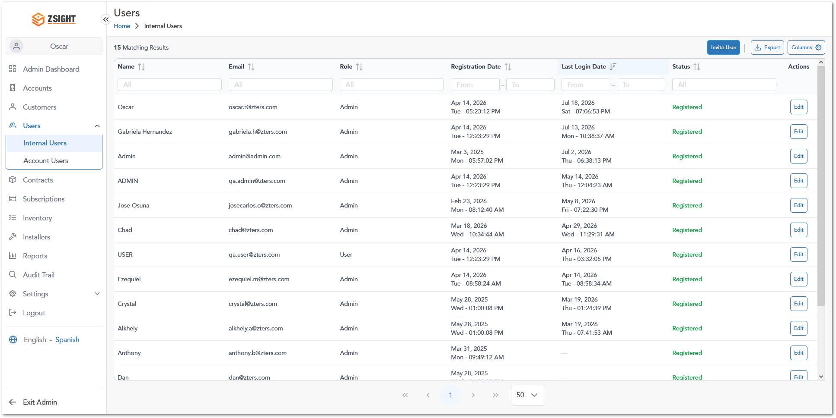
Name | Description
Name | Display the full name of the internal user.
Email | Email address associated with the user account.
Role | Defines the user’s system-wide role and level of access (for example, Admin or User).
Registration Date | Date and time when the user account was created.
Last Login Date | Date and time of the user’s most recent successful login.
Status | Current account status.
Actions | Provides access to user management actions such as editing user information.

Invite Internal User
The Invite Internal User function allows administrators to create new internal user accounts and grant access to the ZSight platform.
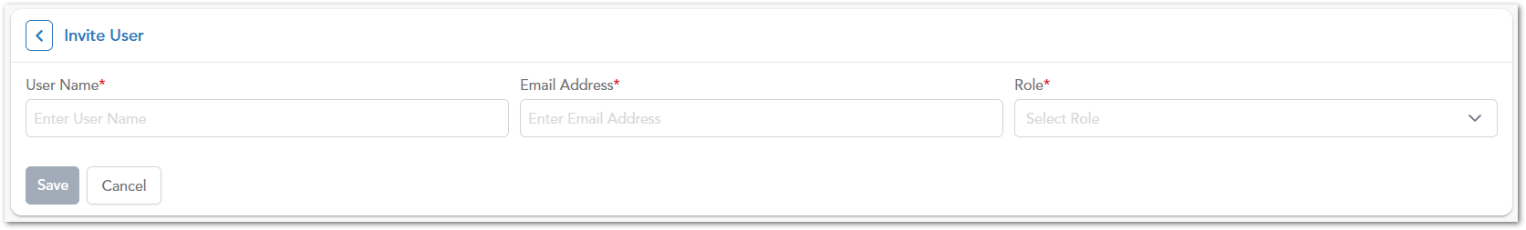
Field | Description
User Name | Full name of the user being invited.
Email Address | Email address that will be associated with the user account.
Role | System-wide role assigned to the user.

Note:
- All fields marked with an asterisk (*) are required.
- The selected role determines the user's permissions within the platform.
- Once created, the user can access ZSight using the assigned account credentials and permissions.

Edit Internal User
The Edit Internal User page allows administrators to modify user information and manage role assignments for existing internal users.
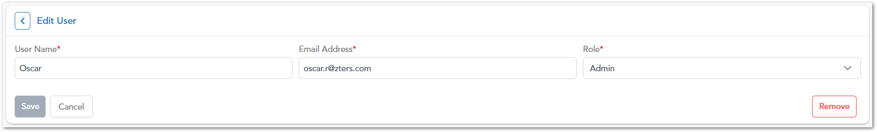
Field | Description
Update User Information | Modify the user’s name, email address, or role.
Save | Applies the changes made to the user record.
Remove | Permanently removes the user from the system.

Note:
- Changes take effect immediately after saving.
- Removing a user revokes their access to the platform.

Account Users
The Account Users section allows administrators to manage users who are associated with one or more customer accounts. Unlike Internal Users, Account Users can have different roles across different accounts, providing flexible access control tailored to customer-specific responsibilities. This section helps administrators maintain account-level permissions while ensuring users have appropriate access to the accounts they support.
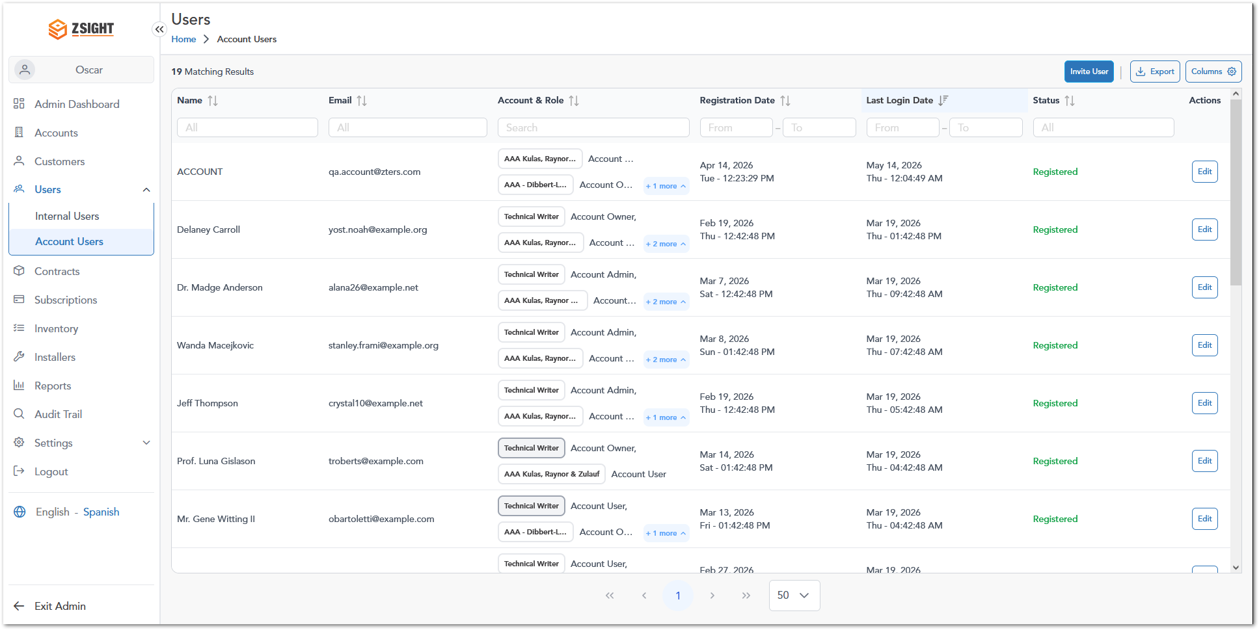
Name | Description
Name | Displays the full name of the account user.
Email | Displays the email address associated with the user account.
Account & Role | Displays each account assigned to the user together with the role granted for that account. A user may have multiple account-role assignments, and each account may use a different role, such as Account Owner, Account Admin, or Account User. When additional assignments are not visible in the row, a +X more indicator displays the number of remaining assignments.
Registration Date | Displays the date and time when the user account was registered in ZSight.
Last Login Date | Displays the date and time of the user’s most recent successful login.
Status | Displays the current registration status of the user account, such as Registered.
Actions | Provides access to available user-management actions. Selecting Edit opens the user record, where administrator can update user information and manage account-role assignments.

Note: Account users can be assigned to multiple accounts. Their access permissions are determined independently by the role assigned to each account.

Invite Account User
The Invite Account User function allows administrators to create new account-level users and assign them to one or more customer accounts.
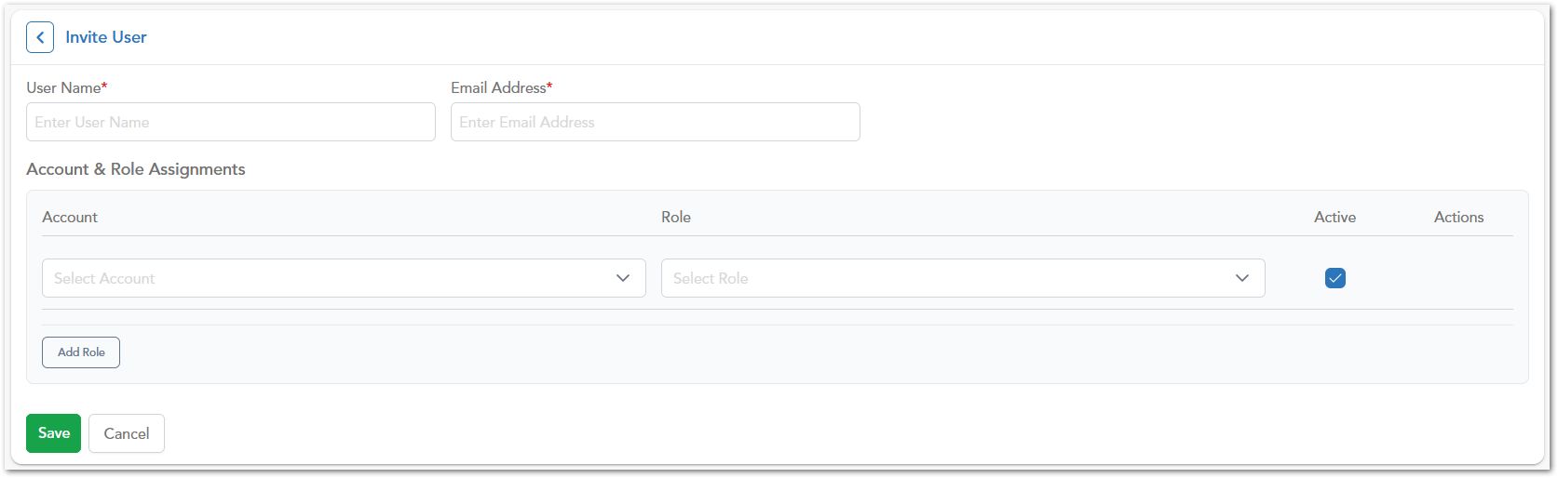
Field | Description
User Name | Full name of the account user.
Email Address | Email address associated with the account user.
Account | Customer account to which the user will be assigned.
Role | Permission level assigned within the selected account.
Active | Indicates whether the assignment is active.

Note:
- A single user may be assigned to multiple accounts.
- Each account assignment can have a different role.
- Multiple account-role combinations can be configured before saving.

Edit Account User
The Edit Account User page allows administrators to manage account assignments and role permissions for existing account users.
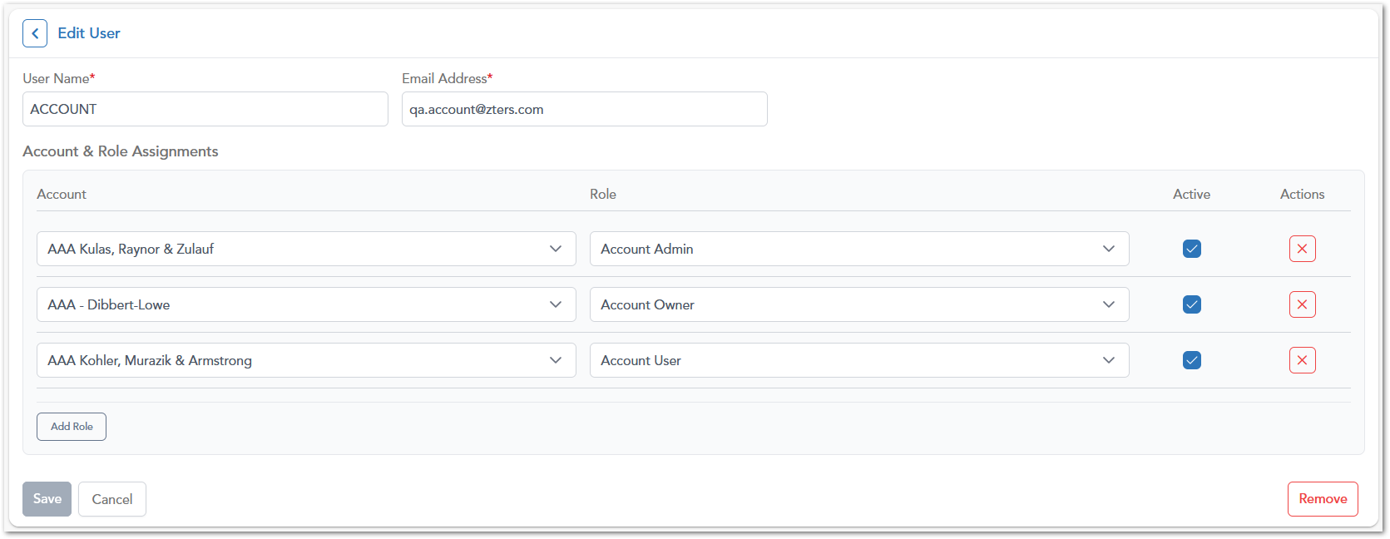
The Account & Role Assignments section displays all accounts associated with the user and the role assigned to each account. Administrator can:
- Modify account assignments
- Change assigned roles
- Enables or disable account access
- Add new account-role assignments
- Remove existing assignments
Note:
- Users may have different roles across different accounts.
- Account assignments can be managed independently.
- Changes take effect immediately after saving.

Contracts
The Contracts module is intended to manage contractual agreements between accounts, customers, and service providers. It will provide visibility into contract terms, durations, and service conditions to support operational and billing processes.

Subscriptions
The Subscriptions module is designed to manage service plans and recurring service agreements associated with accounts or customers. It will enable tracking of subscription details, service frequency, and active service configurations.

Inventory
The Inventory module is intended to manage and track system assets, including containers, devices, and related equipment. It will provide visibility into asset availability, allocation, and lifecycle status.

Installers
The Installers module is designed to manage installer personnel or teams responsible for deploying and maintaining devices and containers. It will support assignment tracking and coordination of installation activities.

Reports
The Reports module is intended to provide access to system-generated reports and analytics. It will allow users to review operational data, monitor performance, and support decision-making through structured insights.

Audit Trail
The Audit Trail module provides a centralized record of changes performed throughout the ZSight platform. It allows administrators to review historical activity across system entities such as Customers, Service Providers, Containers, Users, and other managed records. The modules supports traceability, accountability, and troubleshooting by recording who performed an action, what information changed, and when the changed occurred.
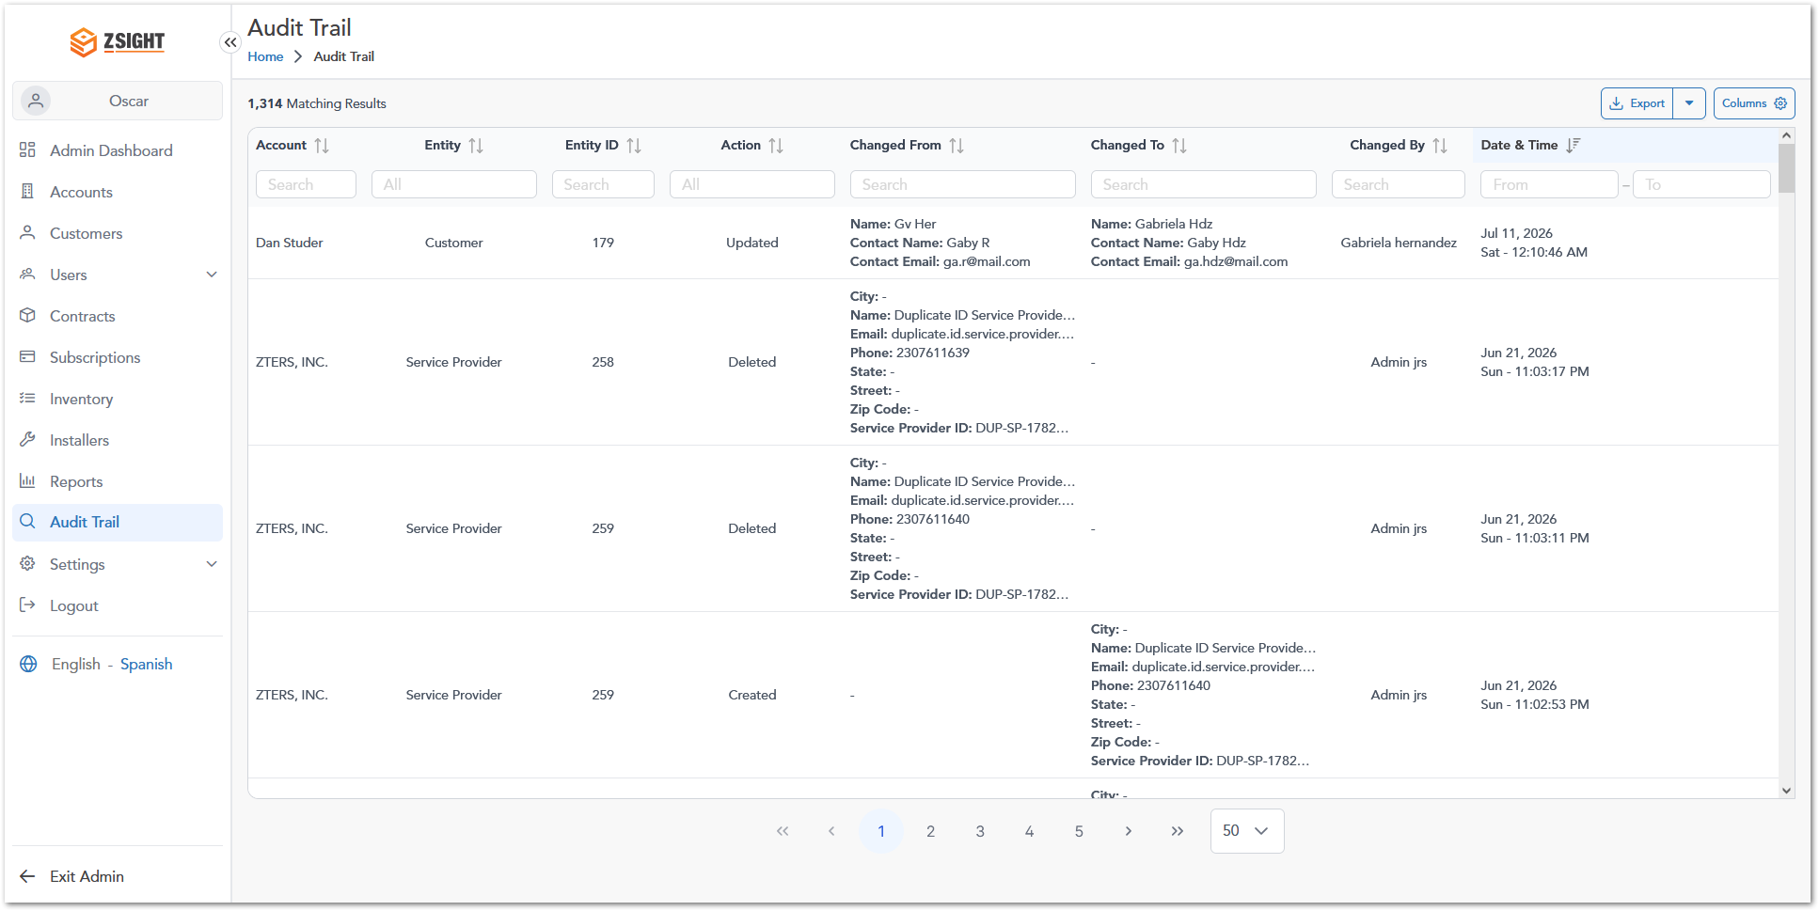
Name | Description
Account | Displays the account associated with the modified record.
Entity | Displays the type of entity affected by the action (for example: Customer, Service Provider, Container, User, or Work Order).
Entity ID | Displays the unique identifier of the affected entity.
Action | Displays the action performed on the entity. Common actions include Create, Update, and Delete.
Changed From | Displays the previous value or state of the entity before the action was performed.
Changed To | Displays the new value or state of the entity after the action was performed.
Changed By | Displays the user who performed the action.
Date & Time | Displays the date and time when the action occurred.

Info: Audit Trail records are read-only and are intended for historical review, compliance tracking, troubleshooting, and administrative monitoring. Records cannot be modified from within the Audit Trail module.

Change Tracking
The Audit Trail module records historical changes performed across the system and displays the previous and updated values associated with each action. This allows administrators to review modifications, identify who performed a change, and verify when the change occurred.
For update operations, the system displays:
- Changed From – The value before the modification.
- Changed To – The value after the modification.
- Changed By – The user who performed the action.
- Date & Time – When the change was recorded.
Depending on the entity being modified, the Audit Trail may capture changes to fields such as names, contact information, service provider details, customer records, user accounts, and other system-managed data.
Note: The Audit Trail module is intended for auditing, compliance, troubleshooting, and historical record review. Audit records are automatically generated by the system and cannot be modified by users.

OVERALL SYSTEM FUNCTIONALITIES

Overall System Functionalities Overview
The Overall System Functionalities section describes common features available across multiple modules within the ZSight application. These functionalities provide users with tools to efficiently navigate, filter, search, and manage data within tables and system views.
The following subsections outline the key shared features that enhance usability and data interaction throughout the platform.

Filter
The Filter functionality allows users to narrow down the records displayed in a table by applying criteria directly to individual columns. Filters are available throughout the application and adapt to the type of data contained in each column.
Depending on the module and column, users can filter information using text values, predefined options, date ranges, numeric ranges, or other data-specific controls.

How it works
Each filter is located directly below its corresponding column header. As filter criteria are entered or selected, the table updates automatically to display only matching records.
The available filter controls vary depending on the type of information displayed in the column.
Filter Type | Example | Description
Text Filter | 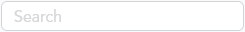 | Allows users to enter free-text values to search for matching records within a column. Results are filtered dynamically as text is entered.
Option Selection Filter | 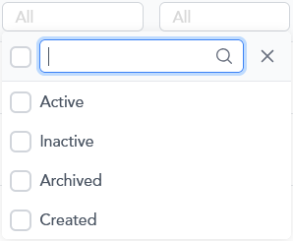 | Displays a list of predefined values that can be selected to filter records. Available options vary depending on the column and module.
Range Slider Filter | 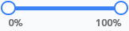 | Allows users to define a minimum and maximum value within a numeric range using a slider control.
Date Range Slider Filter | 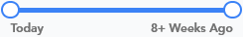 | Allows users to filter records based on relative date ranges using a slider control. For example, service dates can be filtered from Today up to 8+Weeks Ago.
Calendar Date Filter | 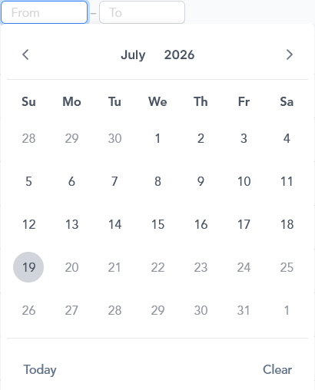 | Allows users to specify a start date (From) and/or end date (To) using a calendar picker.
Formatted Value Filter | 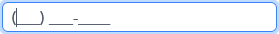 | Used for data that follows a specific format, such as phone numbers. Values must be entered using the displayed format to return accurate results.

Export
The Export functionality allows users to download the records currently displayed in a table for offline analysis, reporting, or data sharing.
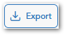
Exported files are generated in CSV (Comma-Separated Values) format and contain the data available within the selected module at the time of export.
Info: Certain Administrator modules, such as Audit Trail, provide two export options:
- Export Visible: Exports only the records currently displayed in the table.
- Export All: Exports all records available in the module.

How it works
To export data:
- Navigate to a module containing a data table.
- Apply any desired filters or searches.
- Click Export.
- The system generates and downloads a CSV file containing the records currently available in the table.
Exported files follow a standardized naming convention to identify the source module, export context, and export date.
Export Type | File Naming Format | Example
Standard View Export | [module]_[YYYY]_[MM]_[DD].csv | customers_2026_07_19.csv
Administrator View Export | admin_[module]_[YYYY]_[MM]_[DD].csv | admin_customers_2026_07_19.csv

Show/Hide Column
The Show/Hide Columns functionality allows users to customize which columns are displayed within a table. This feature is available in modules that display information in tabular format.
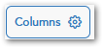
The Columns button is located next to the Export button and displays all available columns for the current module.
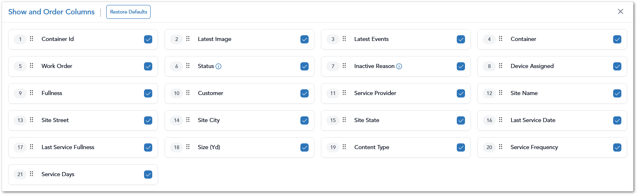

How it works
By clicking the Show/Hide Columns option, a panel is displayed listing all available columns for the current module. Users can:
- Show or hide columns by selecting or clearing the corresponding checkbox.
- Reorder columns by dragging and dropping them into the desired position.
- Restore the default column configuration by clicking Restore Defaults.
Changes are applied immediately and are reflected in the table view.
Info: When exporting data, the generated CSV file includes only the columns currently displayed in the table. Hidden columns are excluded from the export.

User Roles
Role assignation for the application users. It could be presented in a table as follows:
Description | User 1 | User 2 | Admin User
Access to the invoice summary interface 1 | 
Access to the invoice summary interface 2
Access to the invoice summary interface 3

Note: This section is mandatory for all applications with role-based access.

WORKING PROCEDURES
Workflows (including diagrams if applicable) for different options within the application.

Link and Activate a Device
This procedure shows how a device is put into service: it is first linked to a container and then activated. Each command waits for confirmation before the device changes.

If a Link fails, the user reads the reason and tries again. If an Activate is not confirmed within 24 hours, it expires and can be sent again. Activate is needed only when the device is not already active.

Working Procedure 2
Working Procedure 2. (e.g. “Approve request…”)

Working Procedure 3
Working Procedure 3. (e.g. “Generate Report…”)

APPROVAL SIGNATURES
Digital signature blocks below are formatted for DocuSign / Adobe Sign.
Name | Role | Digital Signature Block | Date (dd/mm/aa)
Anthony Bures | Digital Development Manager |  | 22/10/2026

--- END OF THE DOCUMENT ---

